# Increased transparency and documentation of private sector contributions to NDCs



A guide for Reporting and Registry for SD/SDG private sector contribution that is compatible with the MRV/Transparency systems

**May 2021**

# Project title: Increased transparency and documentation of private sector contributions to NDCs

**Deliverable title:** Report on a guide for Reporting and Registry for NDCs/SDG private sector contribution that is compatible with the MRV/Transparency systems

**Authors:**

Fatemeh Bakhtiari (UNEP DTU Partnership, UDP)

Mirko Dal Maso (UNEP DTU Partnership, UDP)

# COPYRIGHT©

# This publication may be reproduced in whole or in part and in any form for educational or non-profit purposes without special permission from the copyright holder, provided acknowledgement of the source is made. UNEP DTU Partnership (UDP) would appreciate receiving a copy of any publication that uses this publication as a source. No use of this publication may be made for resale or for any other commercial purpose whatsoever without prior permission in writing from UDP.

DISCLAIMER

This publication has been produced as part of a component of the Initiative for Climate Action Transparency project (ICAT) implemented by UNEP DTU Partnership (UDP). The views expressed in this publication are those of the authors and do not necessarily reflect the views of UDP

PREPARED UNDER

The project Increased transparency and documentation of private sector contributions to NDCs supported by the Ministry of Foreign Affairs of Denmark Danida

ACKNOWLEDGEMENT:

The authors are grateful to David García, María Paz Cigaran and the whole team at Libélula, Peru for facilitating information regarding the reporting protocols used by the main Latin American private-sector reporters, and to Gordon Mackenzie (UNEP DTU Partnership) and Miriam Liliana Hinostroza Suarez (UN Environment), for comments on the approach to implementing the activity that is the object of this report. The authors are also grateful to the following institution for their input to the methodology assessment via interviews: Gold Standard for Global Goals; Global Reporting Initiative; World Resource Institution; SAM-CSA help line; SASB Standards

REVIEWERS

Sandra Roxana Aparcana Robles

**Introduction**

Climate change embodies an urgent and existential threat to humanity. All countries should upsurge the ambition with which they act to mitigate their greenhouse gas (GHG) emissions and adapt to the anticipated impacts of climate change to secure the future livelihoods of their citizens which should be aligned with sustainable development goals. With this intention, in 2015, nations of the world gathered in Paris to reach a global consensus on the urgent need to reduce GHG emissions and to set national economies on a low-carbon development path. The Agreement which entered into forcé in 2016, requires parties to adopt “fair and ambitious” voluntary actions to combat climate change.

The UN Sustainable Development Goals (SDGs) and the Paris Agreement are two of the most momentous policy frameworks of the twenty-first century. Parties under the Paris agreement have already pledged their Nationally Determined Contributions (NDCs) showing how they will reduce the emissions and achieve targets set by the Paris Agreement. Sustainable Development Goals (SDGs) were originated at the UN sustainable development summit in 2015. SDGs comprise 17 main goals and 169 targets. SDGs said to be a call for all nations to achieve prosperity while saving the planet[1]. Acknowledging the indivisible nature of climate and sustainable development, and the importance of addressing them together to be able to deliver on a just transition, NDCs are increasingly making explicit reference to the links between climate actions and sustainable development.

As part of fulfilling the commitments established by countries under the PA, the development and implementation of systematic frameworks to assess the effectiveness of climate policies and actions is receiving increasing country attention. In this regard, national systems for Measurement, Reporting and Verification (MRV) of GHG emissions and associated co-benefits, to support the development of Mitigation Actions (MAs) based on quality data and scenario simulations, is becoming more common in countries helping them to demonstrate their climate mitigation action.

Currently a number of other programs are being implemented focusing on developing institutional capacity and relevant tools and methods for impact assessment of NDC implementation which can help nations implement the above transparency provisions, including protocols for assessing impacts associated with climate policies and institutional capacity. However, the private sector and other non-state actions are not well reflected in national or international efforts towards Transparency for climate action, let alone sustainable development. For example, what are the sustainable development co-benefits of the climate actions implemented by private sectors? How can the sustainable development impacts of the climate actions be measured? The project “Increased transparency and documentation of private sector contributions to NDCs” aims at filling this gap.

There are two working packages under this project.

1. Prepare a guide for companies wishing to adopt an existing protocol to report on their greenhouse-gas emissions, highlighting common pitfalls (for example, with regard to materiality) and suggesting potential solutions to overcome them.
2. Prepare a guide for companies wishing to adopt an existing protocol to report on the sustainable development impacts from their mitigation actions, highlighting common pitfalls and suggesting potential solutions to overcome them.

In each of the working packages, existing protocols are reviewed and assessed first, from which recommendations are drawn as input to develop guidance. Then, the pros and cons of the best practices were discussed and mapped. This deliverable provides inputs for the second work package above (sustainable development impacts) which aims to provide a guide for companies to adopt existing protocols to report on their sustainable development impacts resulted from their climate actions.

The work is conducted under three steps:

1. Review existing protocols that may be suitable to assess the sustainable development impacts of climate change-mitigation actions in the private sector (i.e. companies), with a view to strengthening the sustainability of these actions.
2. Assess the pros and cons of the selected protocols, to draw best practices and recommendations for future improvement.
3. Prepare a guide for companies wishing to adopt an existing protocol (to report on their sustainable development impacts from their mitigation actions) based on the recommendations above (Transparency guidance).

Figure 1 present the steps in details. This report addresses step 7:

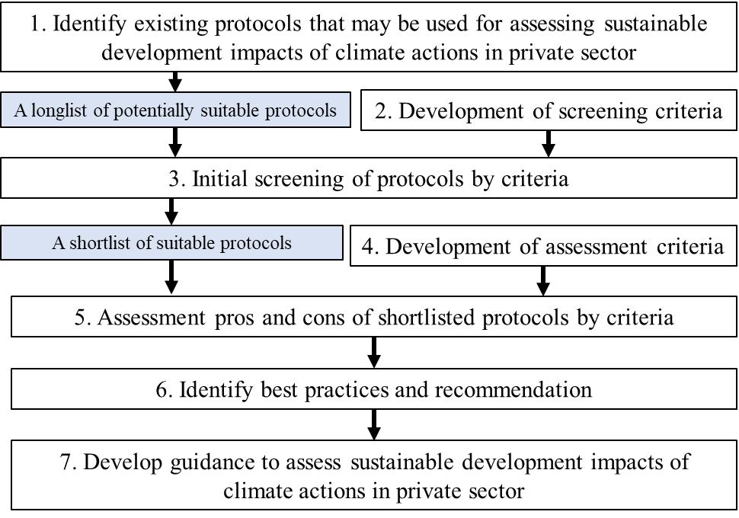

**Figure 1**. Steps to identify and assess existing protocols which can lead to develop guidance to assess the sustainable development impacts of climate change mitigation actions by the private sector. The blue boxes represent results, while the white boxes represent tasks.

This deliverable focuses on step 7, which is the outcome of other steps. Chapter 2 describes the approaches adopted to develop a guide for assessing sustainable development impacts using existing protocols and frameworks. Chapter 3 provides a guide for assessing SDGs' contribution of companies climate actions. Chapter 4 gives suggestions and recommendations

**2. Approach**

According to the assessment and review of existing protocols of steps 5 and 6 (figure 1), it was suggested that the ideal protocol not only should ease the complexity of the process but also it should assure the comprehensiveness of the result. Some protocols provide less complex assessment procedures with limited comprehensiveness of the assessment results because they look into a limited number of sustainable development impacts and do not require to cover all significant and relevant impacts arising from the companies’ climate action. Example of these protocols is GRI series, SASB Standards, Gold Standard and SAM-CSA.

Therefore, the assessment showed that even though ICAT and SMART provide more complex assessment processes that require good expert knowledge to make the choices and carry out the study, the result is also more comprehensive since they allow to cover all potentially positive and negative impacts.

Thus, it was recommended companies follow the assessment steps provided in ICAT-SD framework. ICAT-SD enables companies to apply both qualitative and quantitative assessment. However, ICAT-SD does not offer adequate guidance on how and which method to use for this step. Therefore, the recommendation is to use approaches provided in other protocols such as GRI series and SAM-CSA wherever relevant or to search for approaches in relevant databases such as the SDG Compass business tools, and ICAT database of sustainable development tools and resources. In terms of reporting and communication, even though ICAT-SD provides a template for reporting, the GRI series “addressing investor needs in business reporting on the SDGs” provides good guidance that could be followed. Moreover, a company should always involve key stakeholders, especially top management and possibly sustainability managers in early stages to secure the support needed to carry out the assessment. We recommend using stakeholder participation guidance from ICAT project as good practice.

Therefore this report will focus on the following:

- Identifying the key challenges that companies face when reporting on their sustainable development impacts and identify possible approaches that these companies use to overcome these challenges

- The results from the above help to providing a guide for companies how to use ICAT-SD for SD assessment of their climate actions to **overcome** above challenges ( Introducing ICAT-SD reporting template adjusted for private sectors). The guide will also cover assessment and reporting on companies' SDGs

**2.1 Approach for identifying companies key challenges that companies face when reporting on their sustainable development**

**2.1.1 Interviews**

**Data source:** A qualitative analysis based on semi-structured interviews with senior management representatives of fifteen Latin–American companies from different sectors and types, early-adopters that are leading societal transformation was conducted. It was tried to have a sample of companies which have used different types of protocols.

Participants were asked about "**the key challenges that companies face when reporting on their sustainable development impacts from their actions, and what approaches they use to overcome these challenges**.”

As complementary data collection following alternatives were applied: (1) literature review, (2) interview questionnaires to sustainability leaders of the companies whose senior management representative was interviewed, (3) an online survey to other sustainability leaders for collecting more technical aspects, and (4) meetings’ transcriptions of the sounding board for climate action in Latin America led by nexos+110, are also comprised in the methodology followed by this study.

**Selection criteria**: The private sector in the region is highly diverse; these companies were carefully selected to get a sample as representative as possible. Selection criteria were established based on four main attributes: (1) size, (2) geographical coverage, (3) economic, and (4) sector other attributes independent of company size.

**Table 1.** Criteria and categories for selection of companies

|  |  |  |  |
| --- | --- | --- | --- |
| **Criteria** | | **Categories** | |
| **(1)** | **Size**  For this study, the criteria of every company’s country of origin were taken into account to categorize them according to their size. Commonly, used criteria are: number of employees, annual sales and assets. | Micro  Small & Medium enterprise (SME)  Large | |
| **(2)** | **Geographical coverage**  Refers to the geographical location in terms of the company's headquarters and operations. | Local | Headquarters and operations located within a Latin American country. |
| National | Operations located within their country of origin, that exports to other countries. |
| **(3)** | **Economic sector**  Each sector has its own challenges and level of development. It is important to acknowledge this and study this diversity in order to understand what is possible in terms of climate action, depending on the economic activity they develop. | Food and Drinks, Agroindustry, Consumer Goods, Fishing, Mining, Banking, Textile, Fashion, Retail, Chemical, Water sanitation, Energy, Consultancy, and others.  At least 5 sectors are represented in this study. | |
| **(4)** | **Other attributes independent of company size** | Global | Origin in a Latin American country, but operations in several countries of the world |
| Multi-national | Operations in several countries of Latin America, but origin out of the region (headquarters) |
| Multi-latin | Headquarters located in a Latin American country and operations in several countries of the region. |
| Family | A/few family/ies has/have control over the patrimony and government, which is passed from generation to generation.  (Domínguez, 2012) |
| Start up | Innovation – intensive, high impact and fast – growing companies. |
| Diversified | Operations cover more than one economic sector. |

The discussion with Participants were divided into the below topics, and participants were asked to reflect on them with regards the protocols they use:

* The application context of the protocols they use
* The assessment approaches by the protocols
* The impacts considered
* Requirements on verification and third-party validation
* Consideration of technical details
* Communication and reporting

Below are some of the specific questions were asked from participants:

* What are the strengths and limitations of existing SD reporting methods and initiatives?
* What factors need to be considered to ensure comparability, ease of use and the correct balance of risks, costs and benefits in developing future policies on company SD reporting?
* Why or why not do Latin American private–sector leaders report on their companies’ SD impacts resulted from their climate action?
* What are the incentives that companies expect to report on their SD impacts?
* What are the main challenges that companies in the region face for taking and reporting on their SD impacts as well as SDGs?

**2.1.2 Results:**

**a) Key challenges for SD reporting**

The results come from the interviews as well as literature:

- **General motivations for reporting on SD impacts**: Interviews and data collection revealed that private sector actors in Latin America are varied and have different motivations to participate in climate action initiatives and report on their actions. Some companies decide to take action and report on climate change to increase their profits and build new markets or reduce business risks; others are motivated by policy compliance or investors requirements (Crawford & Church, 2019). These circumstances define their capacity to invest in developing climate action tools and getting involved with reporting initiatives. Some interviewees mentioned that if there were some incentives such as the possibility to get better banking interest rates or the Government recognized it through at least a simple reward system, it would make it more attractive for companies, and more would be willing to disclose their SD impacts. The fact that SD reporting or, in general, reporting on companies climate action is voluntary, according to PA article 6, makes it difficult for some companies to spend time and resources on it if they do not have a critical need for it, such as donors requirements.

Application context: Interviewees made it clear that the SD protocols' application is very much limited to the situation if the climate action is within the scope of the company financial risk. For example, in some cases, even though the projects have not been categorised as Climate Change by the company, they are relevant. Therefore, limiting the use of protocols only from the preliminary category of the projects could limit protocols.

**- The assessment approaches**

* **Complexity of the assessment approaches and, therefore, lack of technical capacities and resources for using the protocol for reporting.** For example, some users of GRI protocol found it challenging to follow the self-prioritization of sustainability impacts, which may be challenging, especially for non-expert users. It was also mentioned that some protocols leave the choice of assessment method to the users and do not provide clear measurement methods, making it challenging for staff to find a proper method to do the assessment. In most cases staffs don’t have technical capacities and skills to do the assessments based on the available protocol guides. Some protocols have been built on different standards and protocols, therefore users require to have a certain level of prerequisite background knowledge before applying the protocol and the majority of interviewees found it too much to expect and is unlikely, particularly for SMEs to have such level of knowledge.

=>It was suggested that maybe a comprehensive manual or a capacity building video can help.

- **The impacts considered**:

The general feedback was there are no clear requirements on the minimum coverage, nor safeguard principles for protocols such as GRI, SASB or SMART. In most cases, they only cover the minimum sets of impacts that are needed in financial reporting and thus, many companies mainly focus on the SD impacts that are relevant to business opportunities and risks, but ignoring the other potential SD impacts.

**- Technical details of the protocols:**

Protocol users unanimously reflected that in most protocols, there is no proper guidance on uncertainty analysis and the avoidance of double-counting.

The supply chain's consideration is not mandatory, which may lead to the ignorance of some significant impacts arising from the supply chains.

Also not detailed information on the baseline and ex-ante scenario are available (e.g. GRI, SASB, SMART). They also mentioned that there are no clear guide on selecting impact categories and defining indicators respectively.

**- Lack of capacity building supports on reporting**

Some of the concerns raised by thte participants were as below:

- They would prefer a protocol that provides user-friendly software to help the users identifying or assessing impacts.

It will also be helpful to have a local or regional contact point in countries to provide supports or directions in using protocols on how to link the SD impacts with SDGs, making it challenging for companies to report on both aspects.

- Lack of publically available user-friendly tutorial; videos or case study examples

- Training programs are not available.

**- Financial resources for reporting:**

According to the companies, conducting the assessments and preparing the reports required some internal human and financial resources. In addition, some protocols are not available for free or asking the protocol providers for support are rather not affordable.

- **Awareness-raising among CEOs and staffs about SD impacts and reporting :**

more than 90% of the interviewees agreed that what would help companies the most to disclose their climate action is to make other private-sector leaders aware of the

value behind reporting. According to what was mentioned by the interviewees,

beyond the brand positioning, the private-sector leaders do not distinguish further benefits

of reporting climate/sustainability actions. How their planning processes and especially

decision making can be better informed towards less carbon-intensive operations are still not

understood by companies. Some of the senior management representatives highlighted that many of their peers find disclosing their climate action worthless and such a significant effort is not rewarded in any way. It was also mentioned that ‘the current schemes of climate action disclosing have been established in a way that does not contribute to businesses, as expected to do so. As a result, it does not become a priority for private sector leaders’.

**b) Key challenges for SDG reporting**

The keyword of the 17 goals of SDGs has been increasingly used and addresses by literature. The SDGs have opened new prospects for innovation, applied research and contributed to sustainable development pillars (Bebbington & Unerman, 2018).

Accounting the SDGs into Corporate Reporting which shaped corporate disclosure for SDGs started by the collaboration between the UN Global Compact and the Global Reporting Initiatives (GRI) in 2018 by releasing a guide (UNGC, 2018). There are different definition available for sustainability, according to the literature. The classic definition dates back to Brundtland, 1987, which describes Sustainable development as a ‘*development that meets the present's needs without compromising future generations' ability to meet their own needs* (Brundtland, 1987: 24). Over the past few years, organisations have started addressing and reporting sustainability in different ways for different reasons such as their commitments to contribute to society beyond financial values (Benn, Dunphy, & Griffiths, 2014). Therefore corporate sustainability is an area in which companies can disclose their contributions to Sustainable Development pillars. As Dyllick & Hockerts, 2002 explain, *' Corporate sustainability can be defined as meeting the needs of a firm’s direct and indirect stakeholders (such as shareholders, employees, clients, pressure groups, communities, etc), without compromising its ability to meet the needs of future stakeholders as well’.*

There are already approaches which companies are using to report on the SDGs. For example, Shields & Shelleman (2015) in their study refer to the use of a type of the SWOT analysis which has been used as a framework for assessing sustain abilities by companies. The assessment tool 'HealRWorld' is another available tool which companies can use to report on their SDGs (see <https://www.healrworld.com>). Other tools such as the B-Corp assessment can be used in certifying if the company meet high standards of sustainability performance[2] and thus a balance performance of achieving profits and SDGs (see https://bcorporation.net/).

However, studies have demonstrated the imperfect involvement of corporates in SDG reporting and more representational/symbolic and international involvement than practical (van der Waal & Thijssens, 2020). There are different reasons involved which could be the voluntary essence of the reporting act and so the lack of enforcement.

Another reason could be the lack of integration of SDGs in companies business and financial model. For example, Cho et al. (2015) argues that many companies, particularly SMEs do not have SDGs as part of their business strategy and mainly include SDGs in their corporate and sustainability reporting symbolically to have a good reputation. This is also supported by a survey from PWC in 2018 in 729 companies globally, which showed 72% of companies mentioned the SDGs in their corporate and sustainable reporting, only 27% included SDGs in their financial strategies. Therefore, if companies don’t have SDGs included in their long-term strategies, they would not have enough incentive to be involved in continuous SDGs reporting.

During the interviews, one of the difficulties raised by most participants was lack of a standard tool which SMEs and bigger entities can use because currently there are a variety of tools and guides that each offers part of the SDG assessment process and not comprehensive and in addition, choosing the best tools and guides aligned with companies situation can be a difficult task for the staffs and time-consuming.

A typical comment we received from our interviews with companies about their ideal tool to integrate in their reporting system was developing a tool that generates a report for them. For example, they only enter their data or answer a series of enquiries or a questionnaire that will enable them to produce a report on their performance in relation to the SDGs. Developing such a tool would possibly increase companies' participation in the global conversation about how different types of companies can contribute to achieving the SDGs by 2030. Figure 2 below illustrates key reasons why SMEs have failed to implement sustainability tools and conduct SDG reporting. The results are based on Johnson and Schaltegger (2016) findings, which were confirmed by our interview results.

SMEs' challenges in reporting SDGs

Lack of motivations from the market

Lack of incentives from the government

External shortcomings

Lack of awareness about sustainability

Lack of CEOs and Staffs' understanding of the benefits of tracking of Sustainable Development

Internal limitations

Lack of expertise as well as human and financial resources in reporting

Complexity of the existing sustainability tools

Time limitations

Lack of proper management tools which follows sustainability concepts

*Figure 2: Reasons for SMEs' failures in implementing sustainability tools and conduct SDG reporting (adopted from Johnson and Schaltegger 2016)*

The above figure 2 confirms the point raised by Kingo[3] (2015), which is the challenge of proposing global sustainability tools for reporting given SMEs' diverse nature.

Based on our findings so far a suitable protocol or assessment tool should contain guidance vis-à-vis the following topics:

* How to identify sustainable development impacts
* How to assess sustainable development impacts
* How to interpret and use the results
* How to link the above to SDGs or to incorporate SDGs in the reporting process

Needless to say that climate action can exist in various forms. Thus, the following features should be covered by a good practice protocol:

* Guidance on how to define the boundaries of the analysis and, by extension, the assessment goals.
* A flexible framework, so that it can be applied to various types of activities, projects, entities, policies, actions, etc.
* Guidance on the consideration of supply chain in the assessment, wherever relevant.
* Guidance on technical methods that are transparent and replicable, as well as scientifically sound.
* Guidance on how to establish and run an independent verification and validation process.
* Relevance to the Sustainable Development Goals

In addition, as it was raised during our interviews, the following elements will be beneficial to have by the good practice guide:

* Provide a software or online tool which helps to generate a report for the user.
* Case study examples.
* Provide a training programme, videos and comprehensive tutorial.
* Offer local contact points, ideally in different countries.

As it was mentioned in our previous report, the following steps are required for companies to take regardless of which protocol they choose:

**Define the purpose of the assessment**. Is it to assess few chosen impacts according to investors’ interests, significance, relevance, etc., or to assess a wider range of impacts wherever possible? Is it for internal use, public reporting, or marketing? How much resources are available? These needs to be well discussed among key stakeholders.

**Properly define the climate action and system boundaries** in accordance with, or adapted from, the protocol requirements.

**Identify the impacts and assessment approaches**. As the impacts stated in these protocols are somewhat limited, companies should also look for other impacts according to the first step's purpose. This may be very challenging for non-experts. If needed, external consultants can be brought in for help.

**Data collection and integration**. This can be very challenging, especially for SMEs that do not have sufficient resources and data to draw from.

**Reporting and communication**. According to the protocols, the reporting can be arranged, bearing in mind to answer the questions defined in step 1.

**2.2 Introducing ICAT-SD reporting template adjusted for private sectors**

According to the assessments of existing protocols conducted by the two former reports: *'*[*Review methods to assess the sustainable-development impacts of climate change mitigation actions by businesses (companies)*](https://unepdtu.org/wp-content/uploads/2021/01/review-methods-to-assess-the-sustainable-development-impacts-of-climate-change-mitigation-actions-by-businesses-deliverable1.pdf)' and ' [*Assessment of selected protocols, report on the pros and cons, and deliver recommendations for future development*](https://unepdtu.org/wp-content/uploads/2021/01/assessment-of-selected-protocols-report-on-the-pros-and-cons-deliverable2.pdf)' in this report, we build our recommended reporting protocol on ICAT-SD for the following reasons. Like other protocol, ICATSD has some downsides that we try to overcome by providing alternative solutions and adjust them to companies' needs as much as possible.

* **Good balance between the process complexity and the comprehensiveness of the results**: The ideal protocol should have a good balance between the complexity of the process and its comprehensiveness. In comparison, ICAT provides more complex assessment processes that require good expert knowledge to make the choices and carry out the study. However, the result is also more comprehensive than all potentially positive and negative impacts should be revealed.
* **Flexibility to identify the assessment goal:** ICAT-SD gives the flexibility to identify the assessment goal that can suit most types of climate actions. The qualitative assessment step in ICAT-SD works as a screening process to help users identify all relevant and significant impacts. However, due to the limited guidance provided in ICAT-SD on identifying those impacts, we recommend users to follow other protocols for this step, especially considering impacts listed in GRI series, SASB Standards, SAM-CSA and SMART.
* **Quantitative methods:** The identified impacts shall be assessed quantitatively to give comprehensive results. Similarly, ICAT-SD does not provide sufficient guidance on how and which method to use for this step. Users are recommended to use approaches provided in GRI series and SAM-CSA wherever relevant. It is also recommended to search for approaches in relevant databases such as the SDG Compass business tools and ICAT database of sustainable development tools and resources.
* **Involving key stakeholders**: the company should always involve key stakeholders, especially top management and possibly sustainability managers, in the early stages to secure the support needed to carry out the assessment. We recommend using stakeholder participation guidance from ICAT project as good practice.
* **Identifying all relevant impacts:** ICAT-SD provides a flexible framework that allows users to identify all relevant impacts. It is suitable for assessing a wide variety of climate actions in the format of, e.g. projects and policies. However, the flexibility also means higher requirements for the users’ expertise. Therefore, Users should also follow the five steps listed above, but with particular attention to identifying impacts and choices of assessment approaches, as they vary case by case without standard options in ICAT-SD. However, this may be time-consuming and challenging. Besides, the language, terms, key concepts and examples in ICAT-SD are public policy-oriented. Company users shall need some translations to understand it within the business context properly.

**Overview of the ICAT SD Methodology for companies[4]**

Below we provide a brief overview of different ICAT SD guidance chapters, which prepare users for applying the Annex X, a self-assessment template.

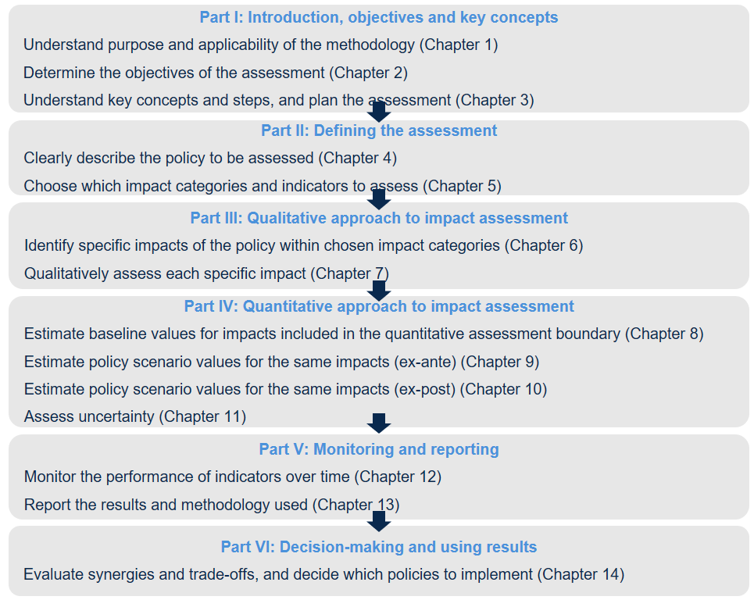

Not all guidance steps require actions by the user when assessing the sustainable development impact of a policy. The following template focuses only on those steps that do.

**Chapter 1: Understand the purpose and applicability of the methodology**

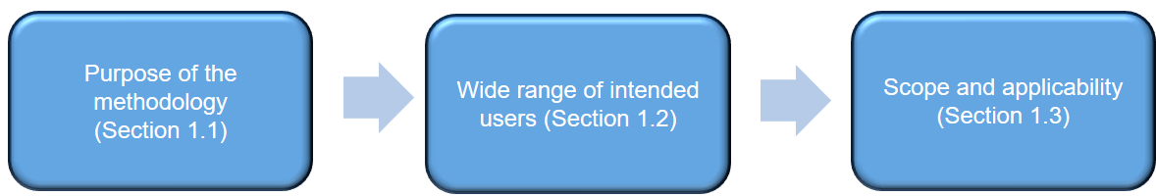

**Purpose of the methodology:**

* Help companies assess all relevant, sustainable development impacts of climate actions in an integrated way, across three dimensions: environmental, social and economic impacts
* Help decision-makers **develop effective strategies** for achieving sustainable development objectives through a **better understanding** of the impacts associated to their actions.
* Support **consistent** and **transparent reporting** of sustainable development impacts

**Scope and applicability**

The scope is assessing sustainable development impacts, which is applicable to all types of climate actions for all sectors.

* + Includes both qualitative and quantitative approaches
  + Covers both forward-looking (ex-ante) and backward-looking (ex-post) assessments
  + Offers a flexible and non-prescriptive approach to accommodate various national circumstances
  + Includes key recommendations to produce high-quality impact assessments
  + Encourages transparent reporting to ensure proper interpretation of the results

**Calculation methods, models and tools**

* The methodology does not prescribe any specific calculation, methods or models and tools to assess climate actions' impacts. However, it provides supplemental resources to use for quantifying specific types of impacts:
  + Excel database of available tools, resources, and models

**Chapter 2. Determine the objectives of the assessment**

Users should identify the intended audience(s) of the assessment report. Possible audiences may include policymakers, civil society organizations, businesses, donors, financial institutions, research institutions or other stakeholders affected by or who can influence the action.

The chapter includes the followings:

**General objectives**

* Identify and promote actions that address multiple priorities, contribute to multiple goals and lead to multiple benefits
* Maximise positive impacts
* Minimise and mitigate negative impacts
* Ensure that climate actions are cost-effective

**Specific objectives**

Ex-Ante Assessment

* **Improve** actions selection, design and implementation
* **Inform** goal setting
* Report
* Access **financing**

**Ex-Post Assessment**

* Assess **actions effectiveness** and improve implementation
* **Learn** from experience and **share best-practices**
* **Track progress**
* Report
* Meet funder requirements

**Chapter 3. Understand key concepts and steps, and plan the assessment**

Overview of the underlying concepts, methodological steps and planning needed for assessing sustainable development impacts of actions.

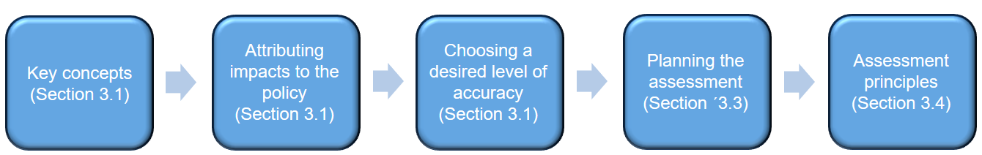

**3.1 Key concepts**

Impact assessment is the **qualitative or quantitative assessment of impacts resulting from an action**.

* Dimension: Overarching category of sustainable development impacts
* Impact category: A type of sustainable development impact affected by an action
* Specific impact: A specific change that results from a policy or action within a given impact category
* Indicator: A metric that can be estimated to indicate the impact of a policy or an action on a given impact category or monitored over time to enable tracking of changes toward targeted outcomes.
* Parameter: Data needed to calculate the value of an indicator in cases where the indicator value cannot be directly measured

**3.1 Attributing impacts on policies**

To estimate an impact resulting from an action:

1. Define the **baseline scenario** and estimate baseline scenario conditions (Chapter 8)

2. Define the **policy and action scenario** and estimate policy and action scenario conditions (Chapter 9 and 10)

3. **Subtract** the baseline scenario value from the policy scenario value to **estimate the impact of policy** or action (Chapter 9 and 10)

**3.1 Choosing a desired level of accuracy**

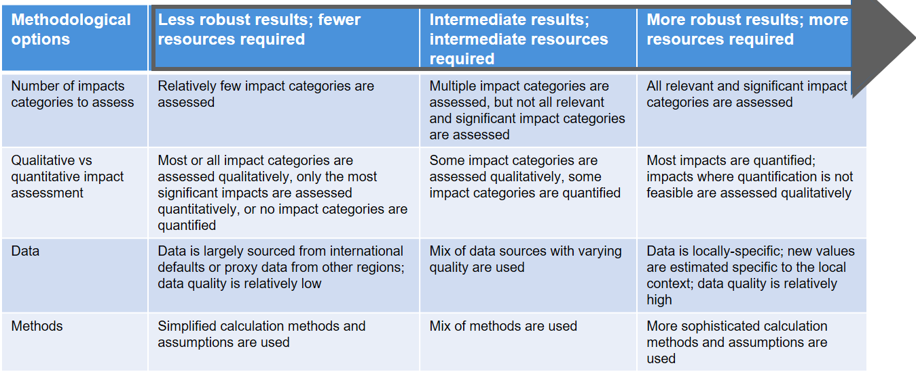

**3.2 Overarching approaches**

The choice of the approach based on the objectives and available resources needs to be reported.

* **Qualitative impact assessment (Part III)**

Description and characterisation of the expected/achieved impacts of an action on selected impact categories using qualitative classifications of likelihood, magnitude and the nature of change (positive or negative).

* **Quantitative impact assessment (Part IV)**

Estimation of the quantitative impacts of an action on selected impact categories relative to a baseline scenario. Quantification includes qualitative impact assessment as a preliminary step.

* **Tracking progress of Indicators over time (Part V)**

Monitoring trends in key indicators over time relative to historical values, goal values and values at the start of policy implementation to track progress in selected indicators over time.

**3.3 Planning the assessment**

* **Data collection**
* **Stakeholder Participation:** Consider how it can support the objectives and include relevant activities. Ensure conformity with national legal requirements and norms for stakeholder participation. Identify stakeholders groups influencing or affected by the policy

**3.4 Assessment principles**

Principles underpin and guide the impact assessment process.

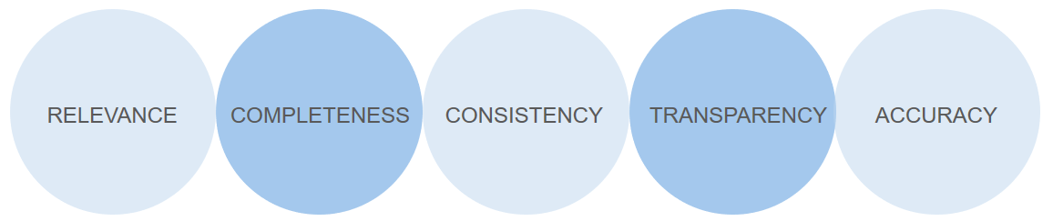

Users should balance trade-offs between principles depending on their assessment objectives. Over time, as the accuracy and completeness of data increases, the trade-off between these principles will likely diminish.

**Chapter 4. Clearly describe the policy or action to be assessed**

It describes the policy or action and deciding whether to perform an ex-ante or ex-post impact assessment of a policy or package of policies.

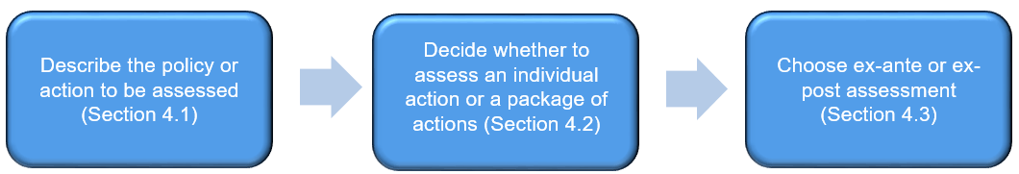

**4.1 4.1 Describe the policy/action to be assessed**

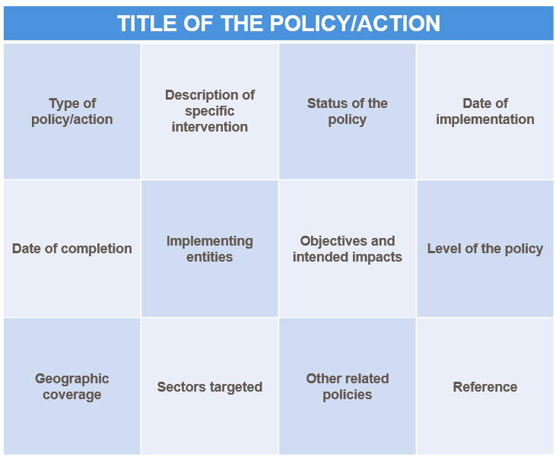

**4.2 Assess a policy or package of policies**

Users should consider possible synergies and trade-offs between actions when deciding whether to assess a single policy or a package of related policies. Assessing a broader package of actions may help avoid possible negative or unintended impacts beyond a single action's scope.

Types of relationships between policies and actions:

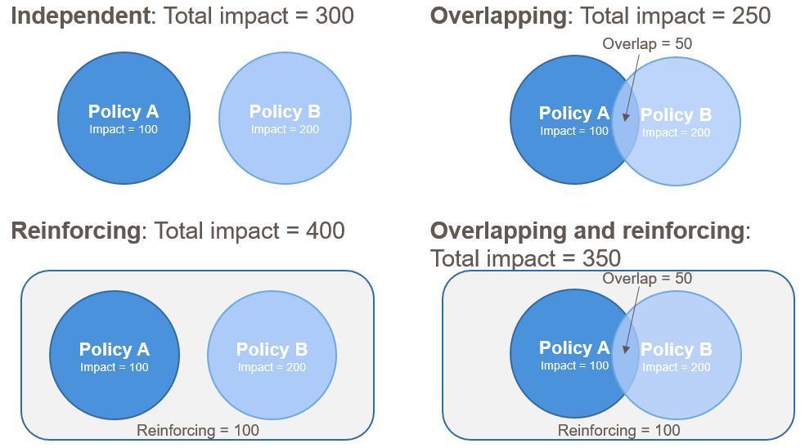

At the end of the assessment, users should also consider potential trade-offs between impact categories in Chapter 14.

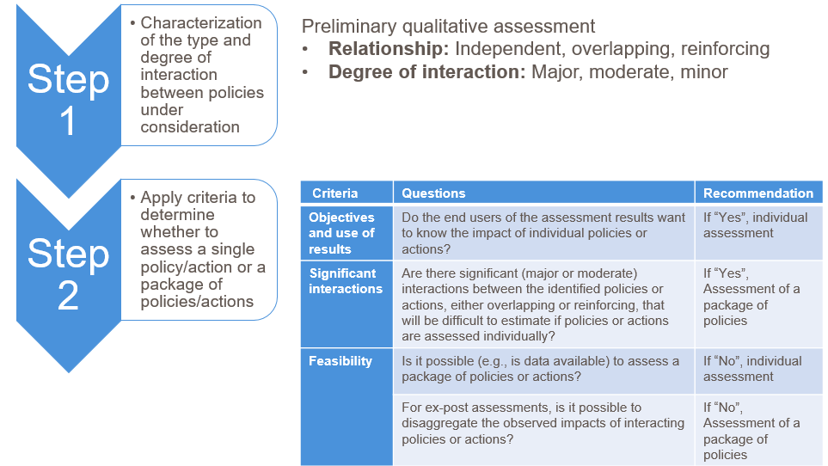

In the context of this project, a company’s climate action is defined as a measure taken by a company to mitigate climate change and strengthen resilience and adaptation capacity to climate risks, thus

contributing to reach SDG 13 (climate action) and the goals set in the Paris Agreement.

The boundaries of the assessment should be set around the climate action that is under consideration, based on this definition. This can, and will, in most cases, concern only some part of the operations of the company (e.g. retrofitting for energy efficiency, or to renewable energy), unless the entire company is considered to “be” the climate action (e.g. in the case of a company producing a climate mitigation product such as renewable energy, afforestation programme, “green” packaging, electric cars, etc.).

The boundaries of the assessment of the sustainable development impacts should align to the assessment boundaries of the assessment of the GHG impacts performed with the NEXOS methodology. For example, if the GHG assessment has attempted to calculate the GHG reductions of an action that the company implements as component of its operations (e.g. retrofitting to more energy-efficient lighting), the sustainable development assessment should consider that as being the action of which the sustainable development impacts will have to be estimated, and users should therefore limit the boundaries of the assessment to the impacts arising from that component of the operations (e.g. the impacts connected to the retrofitting of the lighting system). If, on the other hand, the GHG assessment has focused on calculating the GHG reductions of the product that the company actually provides (i.e. the product of the whole operation of the company), the boundary of the SD assessment should be placed around the company, in order to capture the sustainable development impacts that arise due to the product that the company provides.

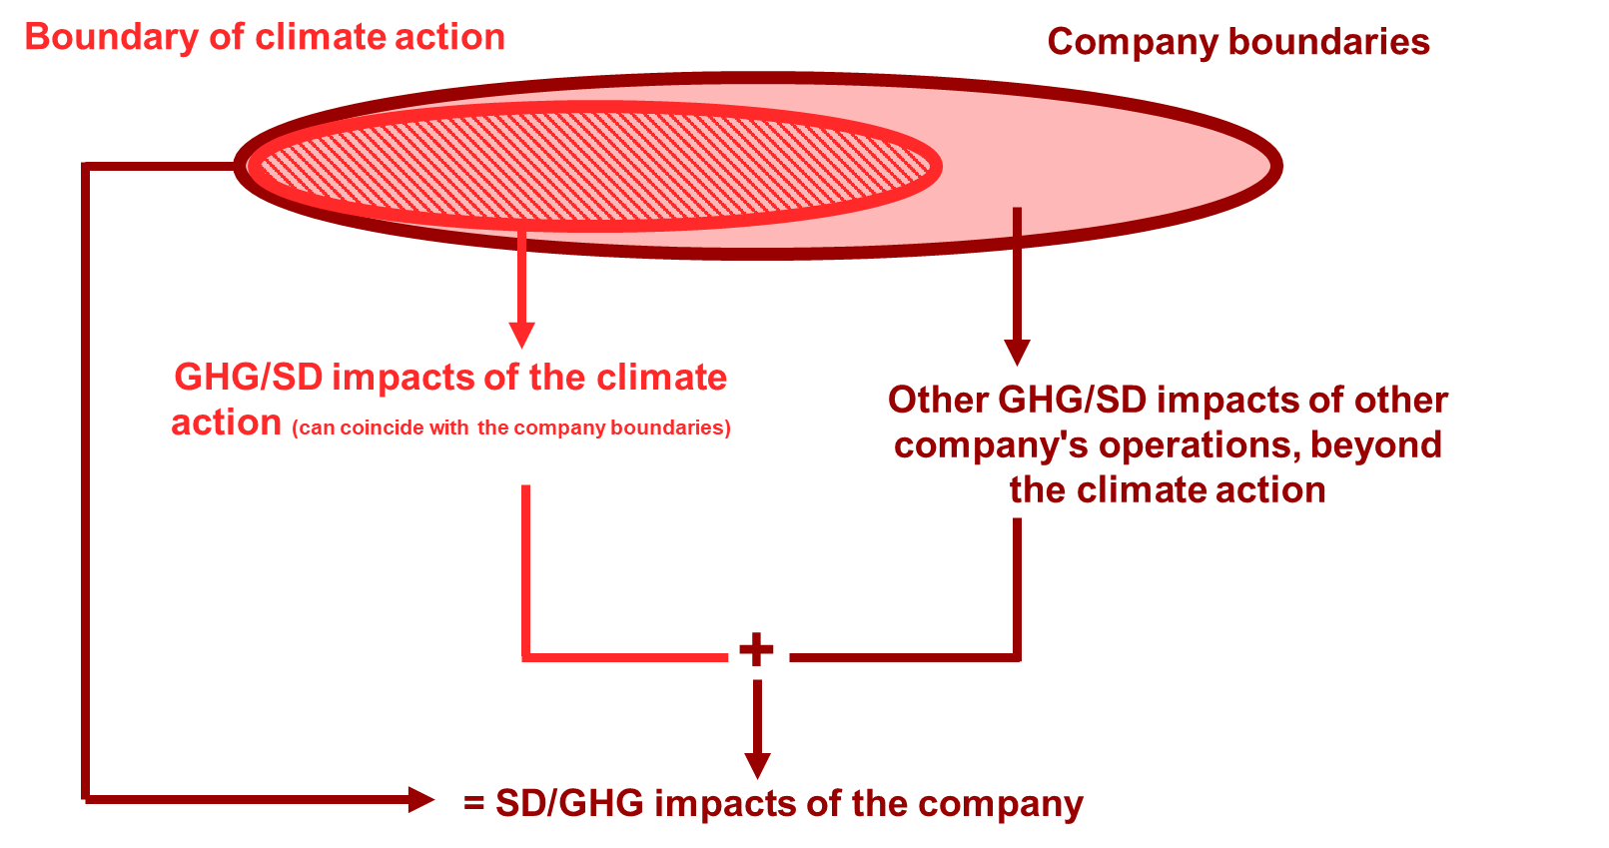

Similar considerations should be also made when selecting the action and baselines scenarios, where both scenarios should be defined in line with how they were defined in the assessment of the GHG reductions.

**Chapter 5. Choosing which impact categories and indicators to assess**

It determines which impact categories to assess and which indicators to use for each included impact category.

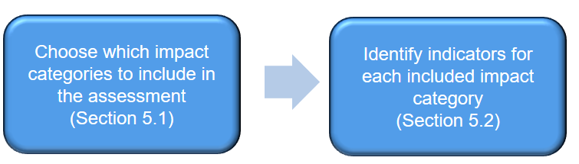

**5.1 Examples of impact categories**

Users should be aware that there are interlinkages and interrelationships between the various sustainable development impact categories

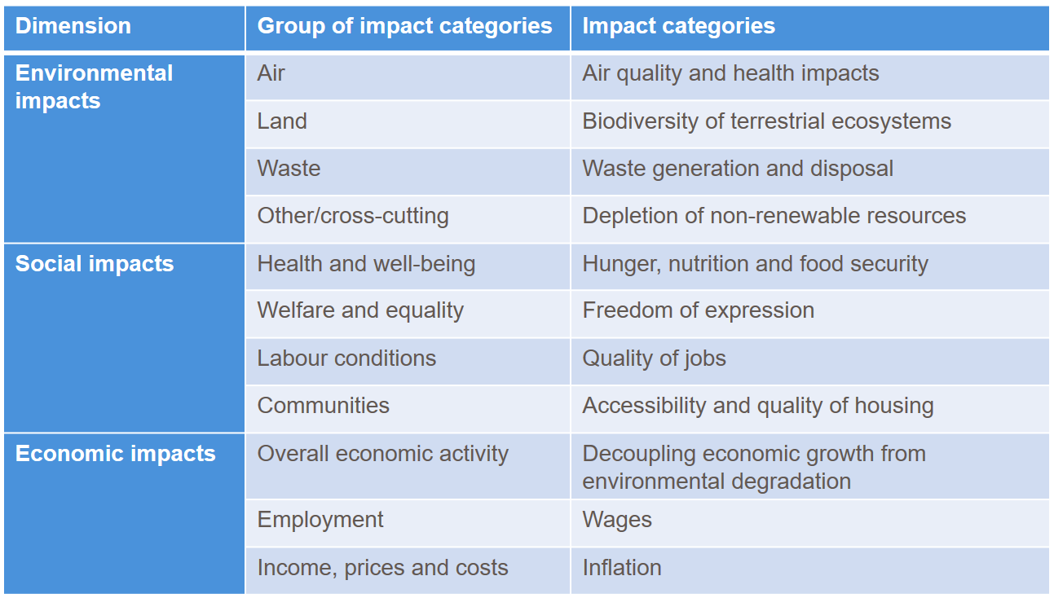

**5.1 Which impact categories to include**

Principled, transparent and participatory choice, in the context of the user's objectives and the needs of stakeholders.

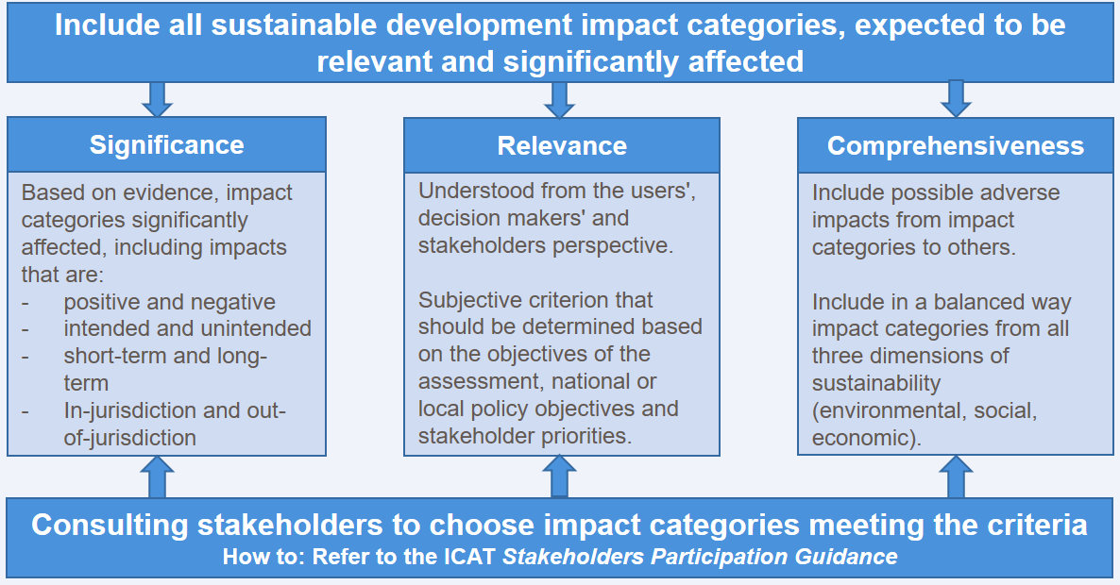

The sustainable development impact categories should be chosen based on what is deemed as significant, and relevant, for the climate action considered.

Users may be tempted to include other relevant and significant sustainable development impacts that the company has, beyond the boundaries of the climate action itself, to showcase how the company contributes to sustainable development. However, if such impact categories are not affected by the climate action, the analysis of the impacts analysed based on the baseline and action scenarios will be the same, and the impact on the selected category will be zero. It is therefore important to remember that this analysis is pursued in to capture the sustainable development impacts of the climate actions, and not necessarily of the company per se.

**5.1 Iterative process for impact categories selection**

Stepwise and iterative prioritization process for identifying impact categories and specific impacts

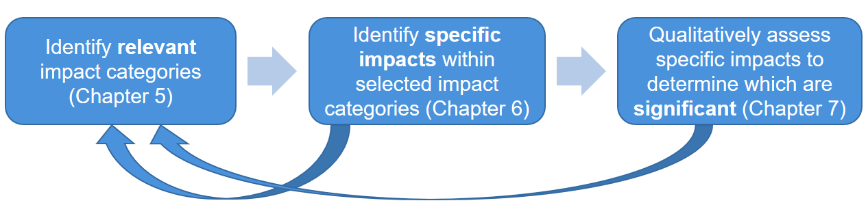

Beware of interlinkages and interrelations between impact categories.

**5.1 Reporting the selection choice**

It is about reporting to ensure transparency and increase the legitimacy, usefulness and replicability of the assessment.

* Reporting template to justify the choice of which impact categories are included in the assessment.
* Justification for exclusions of impact categories that may be relevant, significant, or identified by stakeholders.

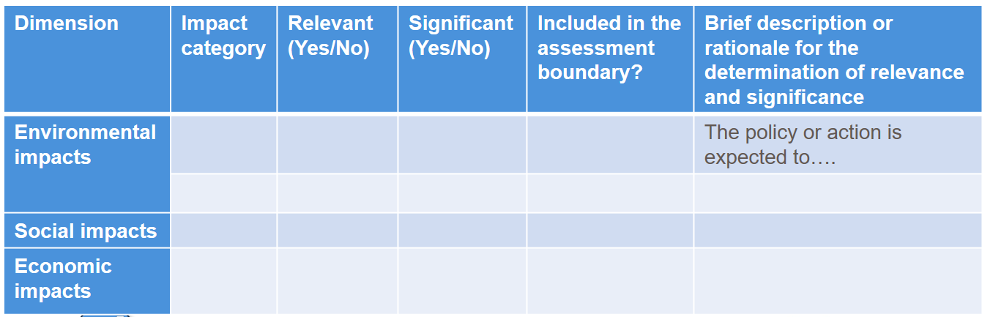

**Chapter 6. Identify specific impacts of the policy or action within chosen impact categories**

This step is relevant for all users, including those following qualitative and quantitative approaches, for either ex-ante or ex-post assessment. For all users, the set of impacts identified in this chapter will be included in the qualitative assessment boundary and qualitatively assessed in Chapter 7. For users following a quantitative approach, it is not necessary to estimate all of the impacts identified in this chapter. Instead, the qualitative assessment step in Chapter 7 will be used to determine which impacts are significant and therefore recommended to be included in the quantitative assessment boundary and estimated (in Chapter 8). It is important to comprehensively consider all potential impacts in this chapter before setting the quantitative assessment boundary.

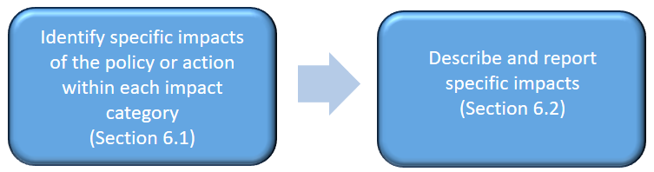

To ensure comprehensiveness, identified impacts should be: Positive and negative, Intended and unintended, In- and out-of-jurisdiction, Short term and long term

**6.1 In- and out-of-jurisdiction impacts**

In certain cases, a single impact may be both in-jurisdiction and out-of-jurisdiction and separate tracking may not be feasible. Alternatively, users can apportion the impact between in-jurisdiction and out-of- jurisdiction based on assumptions.

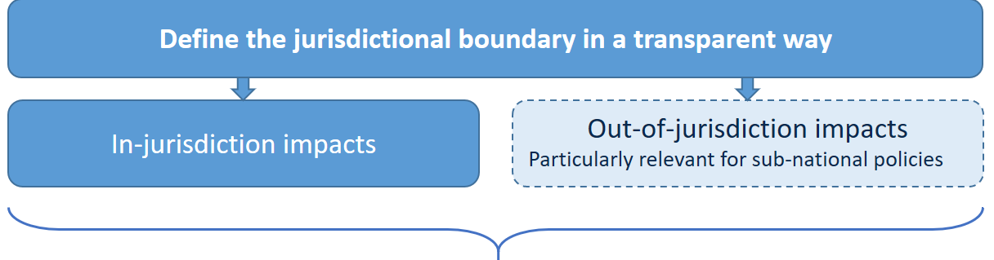

**Separate tracking of impacts when feasible can:**

* Help link the policy or action to the implementing jurisdiction's sustainable development goals
* Address potential double counting of out-of-jurisdiction impacts

Here, jurisdiction is intended as the physical boundaries of the company itself. The GHG Protocol, which deals with assessment of GHG footprint of companies categorises emissions according to Scope 1, 2, and 3. As this sustainable development assessment is an add-on to the assessment of the GHG emissions reductions, users may choose to further categorise the jurisdiction of the impacts, based on the Scopes of the GHG Protocol, thus dividing them into:

* Scope 1: Direct GHG emissions (or sustainable development impacts) from sources that are owned or controlled by the company.
* Scope 2: Indirect GHG emissions (or sustainable development impacts) from electricity, heating and cooling, consumed by the company.
* Scope 3: Other indirect GHG emissions (or sustainable development impacts) occurring from sources not owned or controlled by the company. Examples of scope 3 activities are extraction and production of purchased raw or manufactured materials necessary for the company, construction of buildings, transportation of purchased fuels, and use of products, services, and waste materials of the company to the end of the life cycle.

Sustainable development impacts happening in Scope 1 can be considered as being “In-jurisdiction impacts”, while Scope 2 and 3 can be considered our-of-jurisdiction.

**6.1 Causal chains for identifying and organizing specific impacts**

A variety of methods may be used to identify specific impacts resulting from the policy or action, including developing a causal chain and using an impact matrix table. For either approach, stakeholder consultation, literature review, and expert judgment can be used to identify impacts. These methods are not mutually exclusive and should be used in combination to identify all potential impacts.

* **A causal-chain:** Conceptual diagram articulates the process by which the policy or action leads to various sustainable development (SD) impacts through a series of interlinked logical and sequential stages of cause-effect relationships.
* **Purpose:** identifying, organizing and communicating all potential sustainable development impacts of a policy or action in all identified impact categories.
* **Why use it:** Tool to enhance policy design, improve understanding of policy effectiveness, communicate the impacts of the policy to stakeholders

**Option 1: Single causal chain with all SD impact categories**

* Limited specific impacts and interrelated impact categories
* It might not include all specific impacts since too complex

**Option 2: Separate causal chains for each impact category**

* Relatively unrelated impact categories with no intermediate impacts in common
* It does not illustrate the relationships between impact categories

**6.1 Causal chains for identifying and organizing specific impacts**

Users can either develop (1) a single causal chain that contains all sustainable development impact categories included in the assessment, or (2) separate causal chains for each impact category, depending on what is most appropriate for a given situation.

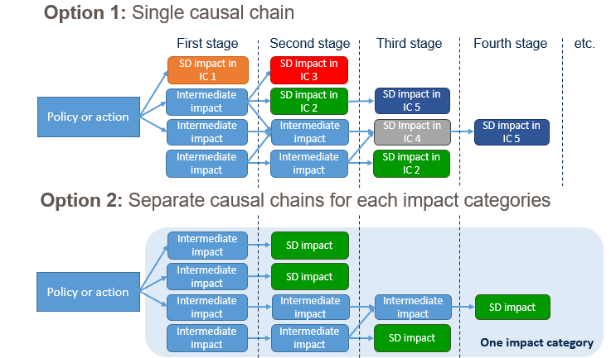

To develop the causal chain, users should first identify the proximate (first stage) impacts of the policy or action. It may be helpful first to consider the inputs or resources made available to implement the policy or action and the activities involved in implementing the policy or action to help identify the proximate (first stage) intermediate impacts or changes in behaviour, technology, process. Each first-stage impact represents a distinct “branch” of the causal chain. Each branch of the causal chain may lead to one or more intermediate impacts or sustainable development impacts. Users should extend each branch of the causal chain through a series of cause-and-effect relationships—that is, a series of intermediate effects—until it leads to all potential sustainable development impacts in the selected impact categories, to the extent feasible.

It is possible that a sustainable development impact in one category may lead to another sustainable development impact in another category.

**6.1 Literature review, stakeholder consultations and expert judgement**

Additional literature that may be useful includes regulations, development plans, regulatory impact analyses, environmental impact assessments, risk assessments and economic studies. It may also be useful to refer to sector- and/or impact-category-specific assessment guidance or methods. The ICAT website provides references to 12 methods and models for assessing specific impacts, which can help users identify impacts

**6.2 Describe and report specific impacts**

Communicating all identified impacts helps stakeholders and decision-makers understand the various impacts of the policy or action and helps users determine the most relevant impacts to assess in a transparent and consistent manner.

Reporting of all identified impacts should be made with a causal chain and a table format.

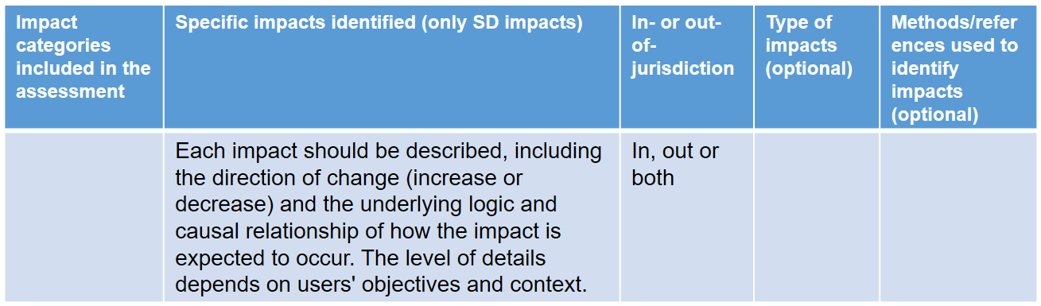

**Chapter 7. Qualitatively assess each specific impact**

To assess the transformational impacts of a policy or action, users need to describe the policy or action that is assessed, decide whether to assess an individual policy or action or a package of related policies or actions and choose whether to carry out an ex-ante or ex-post assessment. This chapter also explains how to define the assessment boundary and assessment period.

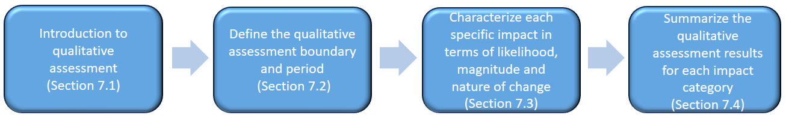

**7.1 Introduction to qualitative assessment**

*Qualitative data* is descriptive and can be used to describe concepts that are harder to measure, such as quality, behaviour or experiences.

*Quantitative data* is measurable and can be used to measure or estimate quantities such as cost, time, area and energy.

In some instances, qualitative assessments can be more subjective and uncertain than quantitative assessments and, therefore, could lead to inaccurate and misleading results without combining them with a quantitative assessment. Depending on the sampling level from different stakeholder groups, qualitative assessments can also be limited in coverage and therefore non-representative of broader conditions or impacts, which can produce less reliable results with less ability to generalize impacts. Therefore, it can be helpful to use a combination of qualitative and quantitative data and approaches. The suggestion is to keep qualitative assessment as a base and performing quantitative assessment to the extent possible.

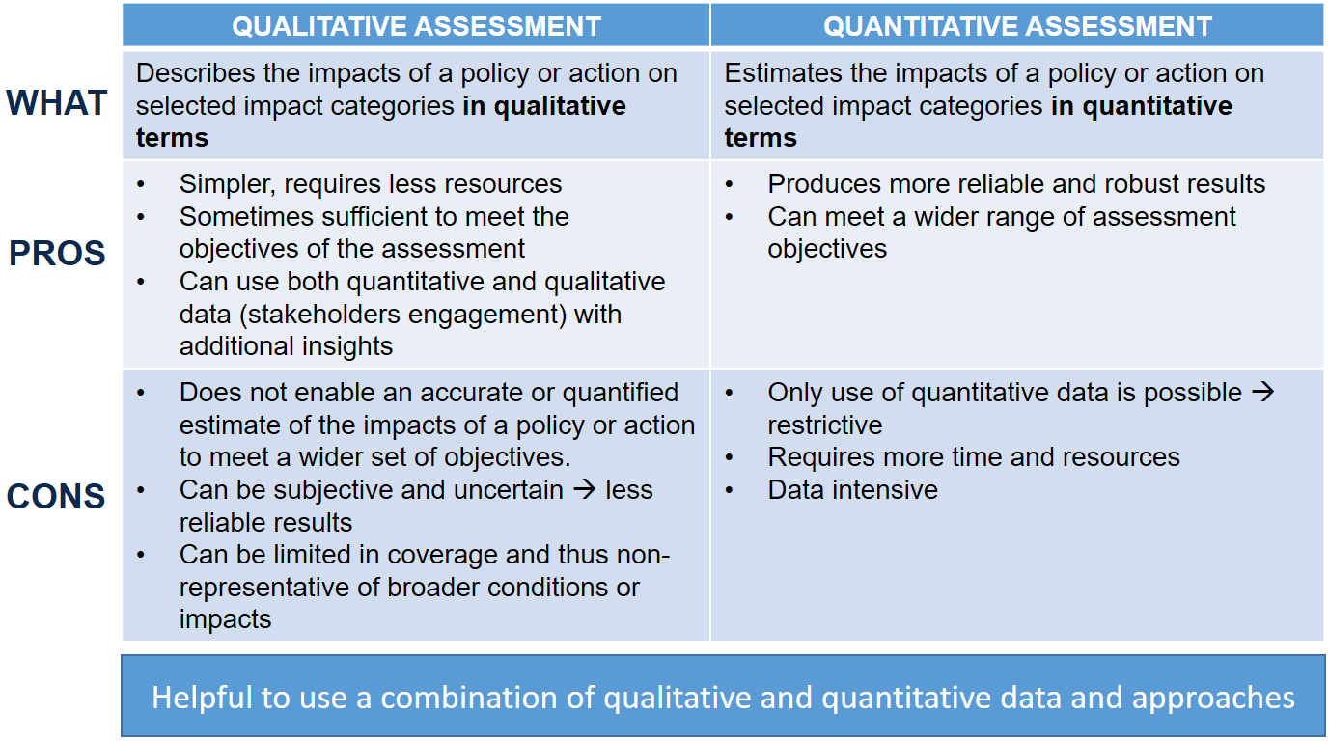

The *qualitative assessment boundary* defines the scope of the qualitative assessment in terms of the range of dimensions, impact categories and specific impacts that are included in the qualitative assessment. The qualitative assessment boundary should always align with the boundary of the climate action under assessment. When assessing the impacts of the action qualitatively, a detailed description of the baseline and action scenario is not required. However, users should always assess the likelihood and magnitude of the impacts in comparison to the baseline scenario (i.e. the most likely to happen scenario, in the case in which the climate action is not implemented).

**7.3 Characterize each specific impact:**

**Step 1: Assessment of the likelihood the impact will occur**

For *ex-ante assessments*, this involves predicting the likelihood of each impact occurring in the future as a result of the policy or action.

For *ex-post assessments*, this involves assessing the likelihood that the impact occurred in the past as a result of the policy or action, since impacts may have occurred during the assessment period for reasons unrelated to the policy or action being assessed.

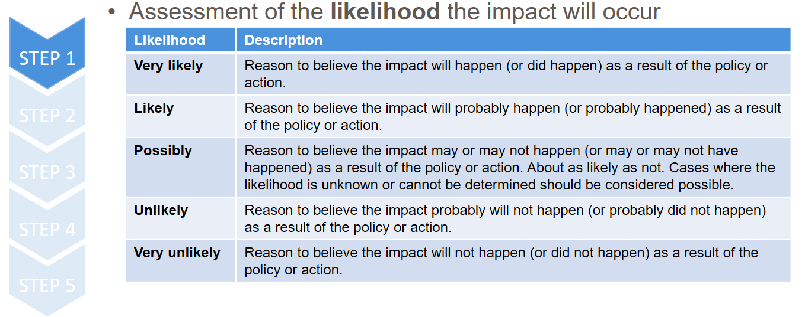

**Step 2: Assessment of the magnitude of the impact based on evidence.**

Magnitude represents the degree of change resulting or expected to result from the policy or action. In general, users should assess the magnitude of each impact relative to the broader conditions related to a given impact category (such as the total level of air pollution in a region or the total number of jobs) rather than in comparison to other impacts resulting from the policy or action. Determining whether an impact is major, moderate or minor requires comparing the expected impact to a reference point. Users should choose a reference point that produces the most meaningful results based on the specific context and circumstances.

Users can also classify impacts as major, moderate or minor in relation to the maximum level of impact considered feasible from various policy options available in a jurisdiction (e.g., the maximum level of air quality improvement or job creation considered feasible and realistic). Users should report the approaches and reference points used to determine the magnitude of impacts.

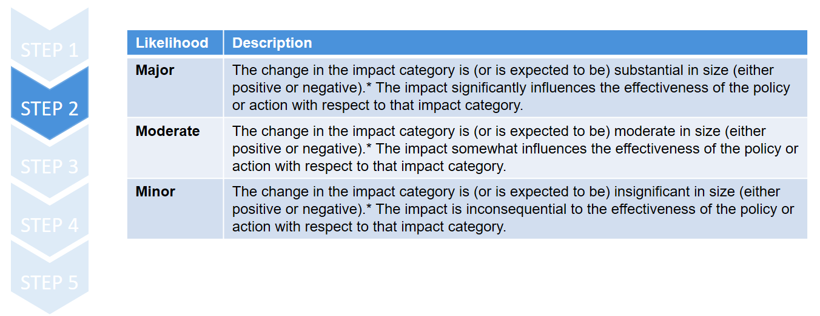

**Step 3: Combination of likelihood and magnitude to determine significance**

Users should consider impacts to be significant unless they are either minor in size or unlikely or very unlikely to occur (see table). Depending on the context and assessment objectives, users can adopt other approaches to determining the significance of impacts, such as considering unlikely impacts that are major or moderate to be significant.

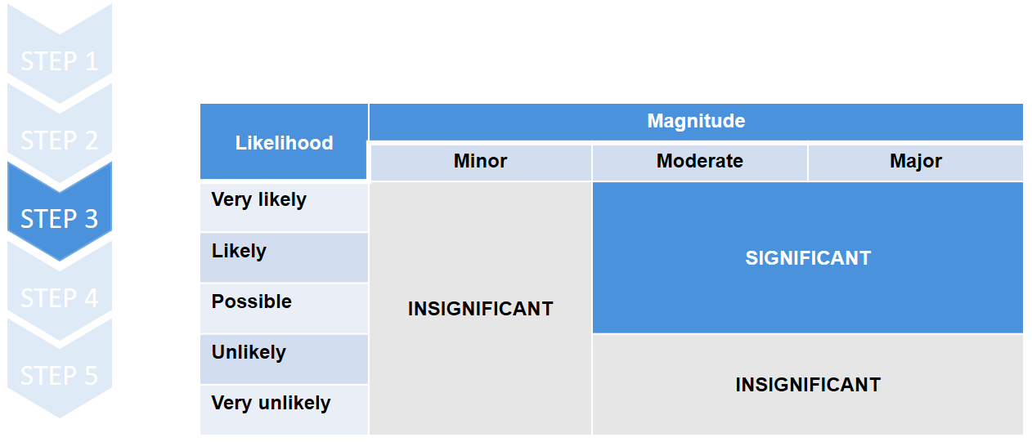

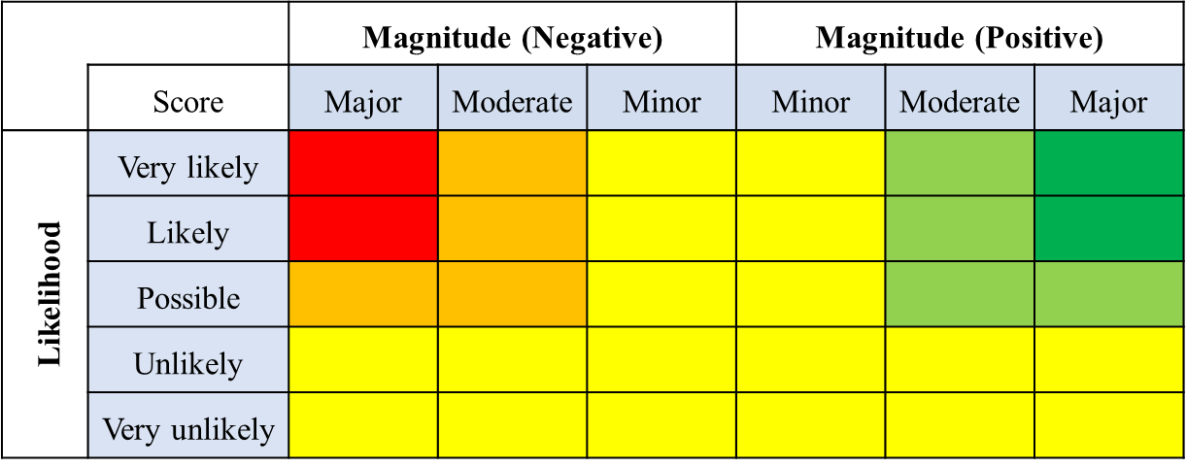

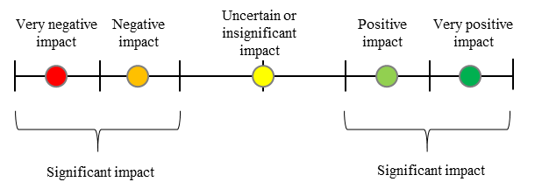

**Step 4: Determine the nature of change**

* + Impacts are either positive, neutral or negative.

**Step 5: Report the results**

* + Use of the reporting template

**Chapter 8. Estimate baseline values for impacts included in the quantitative assessment boundary**

This part is of the guidance is relevant to both ex-ante and ex-post assessment and provides guidance on estimating ex-ante and ex-post baseline scenarios.

Quantifying the sustainable development impacts of an action requires a *reference case*, or *baseline scenario*, against which impacts are estimated. The baseline scenario represents the events or conditions that would most likely occur in the absence of the action being assessed. Properly estimating baseline values is a critical step, since it has a direct effect on the estimated impacts of the action. In this chapter, users estimate baseline values for each indicator included in the quantitative assessment boundary. This chapter is relevant to both ex-ante and ex-post assessment and provides guidance on estimating ex-ante and ex-post baseline scenarios.

Both the baseline and action scenarios should be defined in alignment with how they were defined in the assessment of the GHG impacts.

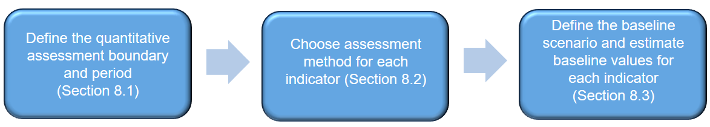

**8.1 Define the quantitative assessment boundary and period[5]**

In general, users should not exclude any impacts from the quantitative assessment boundary that would compromise the relevance of the overall assessment.

Users should ensure that the assessment appropriately reflects the impacts resulting from the policy or action and that it serves the decision-making needs of users of the assessment report. Exclusions may lead to misleading and biased results and not accurately represent the impacts of the action. Where possible, instead of excluding significant impacts, users should use simplified or less rigorous estimation methods to approximate each impact or use proxy data to fill data gaps. Any significant impacts that are not quantified should be described qualitatively.

**8.2 Choose an assessment method for each indicator**

Users can apply a different method for each indicator being assessed.

* The **baseline scenario**, which represents the events or conditions most likely to occur in the absence of the policy or action (or package of policies and actions) being assessed.
* The *policy/action scenario*, which represents the events or conditions most likely to occur in the presence of the policy or action (or package of policies and actions) being assessed.

In the **scenario method**, the baseline scenario depends on assumptions related to key impact drivers over the assessment period. Drivers include other policies or actions that have been implemented or adopted, as well as non-policy drivers, such as economic conditions, energy prices and technological development. Baseline scenarios can be determined ex-ante or ex-post[6].

**8.3 Estimate baseline values for each indicator**

Users may find it most useful to follow the steps in this section separately for each impact category being estimated, since the choices made regarding methods and data are likely to be different for each impact category being assessed. In this case, users should complete the steps for one impact category at a time, then repeat the process for each impact category included in the assessment. Involving stakeholders in the selection and estimation of baseline scenarios is important to ensure credible assumptions and valid results.

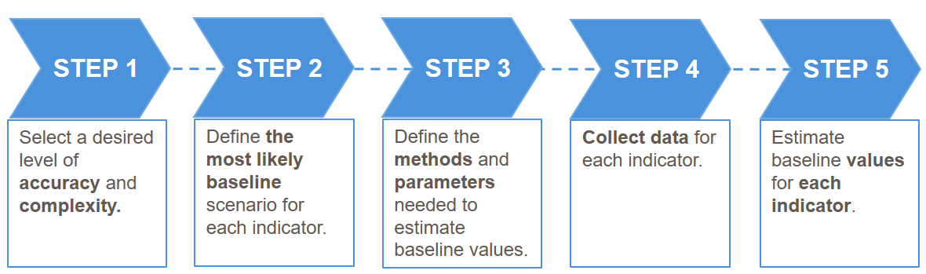

**Chapter 9. Estimate policy/action scenario values for the same impacts (ex-ante)**

In this pat, users estimate policy scenario values for the indicators included in the assessment boundary. The impacts of the policy or action are estimated by subtracting baseline values (as determined in Chapter 8) from policy scenario values (as determined in this chapter). Users not quantitatively assessing impacts ex-ante can skip this chapter.

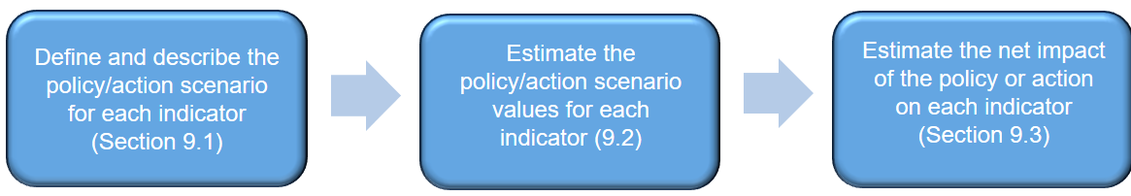

9.1 Describe the policy/action scenario for each indicator

The policy scenario represents the events or conditions most likely to occur in the presence of the policy or action (or package of policies or actions) being assessed. The only difference between the baseline scenario and the policy scenario is that the policy scenario includes the changes caused by the policy or action (or package of policies/actions) being assessed.

Users should identify various policy scenario options and then choose the one considered to be the most likely to occur in the presence of the policy or action. It is important to consult stakeholders during the selection and estimation of the policy scenario to ensure credibility. Users should report a description of the policy scenario for each indicator being estimated.

9.2 Estimate policy scenario values for each indicator

To estimate policy scenario values for each parameter, users should first identify which parameters are affected by the policy or action. Parameters that are affected by the policy or action (such as quantity of energy consumed) need to be estimated in the policy scenario. These parameter values are expected to differ between the policy scenario and baseline scenario. Users should follow the same general steps described in Section 8.3 for estimating baseline values but should instead estimate the policy scenario value for each parameter. This requires developing assumptions about how the policy or action is expected to affect each parameter over the assessment period.

9.3 Estimate the net impact of the policy on each indicator

Users should calculate baseline values, policy scenario values and the net impact of the policy over defined time periods (e.g. annually) and cumulatively over the quantitative assessment period.

The change due to the policy is expressed in a neutral estimate of impact, which may either be an increase (positive value) or a decrease (negative value). Policy scenario values may be either higher or lower than baseline scenario values, depending on the impact being estimated.

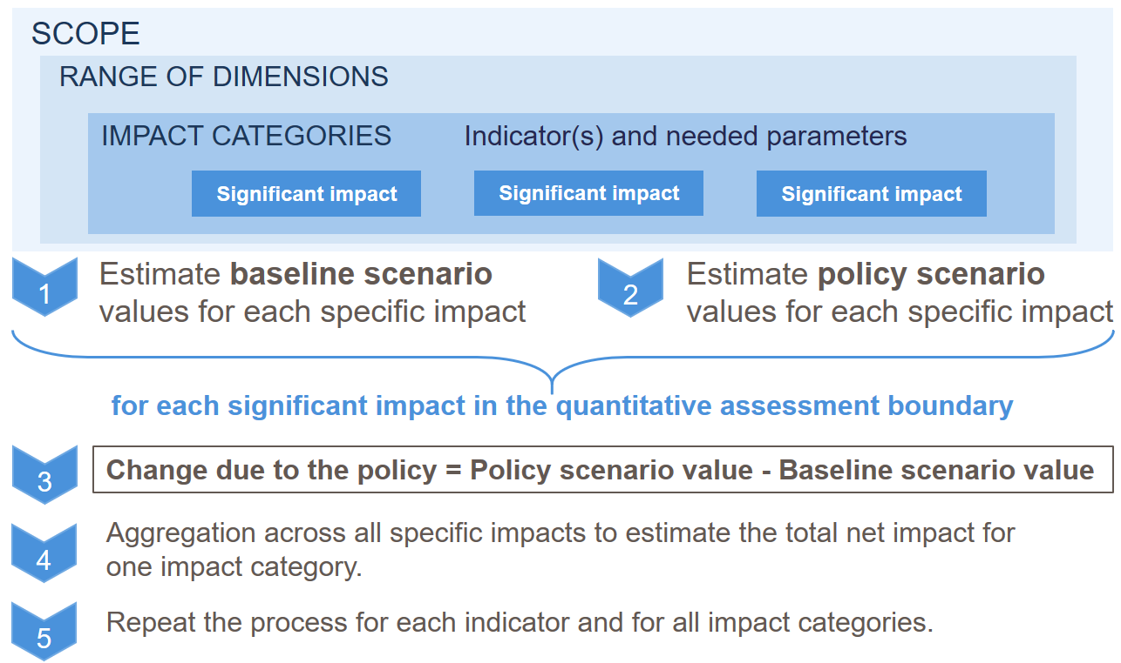

**Chapter 10. Estimate policy scenario values for the same impacts (ex-post)**

Users estimate the impact of the policy by comparing observed policy scenario values of an indicator (based on monitored data) with ex-post baseline values (described in Chapter 8). Unlike ex-ante assessment, which involves forecasted values, ex-post assessment involves monitored or observed values. The impact of the policy (ex-post) is estimated by subtracting baseline values from policy scenario values. Users who are not quantitatively assessing impacts ex-post can skip this chapter.

**Sections 10.1–10.4** apply to users following the **scenario method**, while **Section 10.5** applies to users following the **comparison group method**.

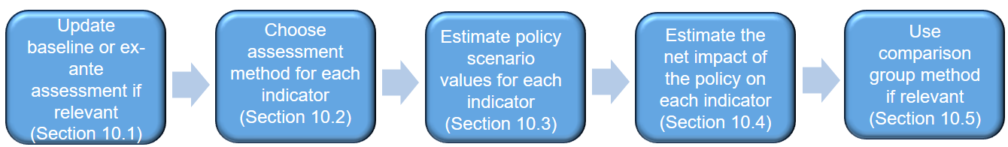

10.1 Update baseline values or ex-ante assessment

If an ex-ante assessment for the policy was previously carried out, the same method can be used for the ex-post assessment, by replacing the forecasted indicator values (ex-ante) with observed indicator values (ex-post). Alternatively, users can apply a different method to estimate policy scenario values. Users should choose the method that yields the most accurate results. If both an ex-ante and an ex-post assessment are carried out for the same policy at different times, each assessment will likely yield different estimates of the impacts of the policy, since the observed (ex-post) indicator values will likely differ from assumptions forecasted in the ex-ante scenario.

10.2 Choose an assessment method and estimate values for each indicator (10.3)

Users should ensure consistency in the methods used to estimate baseline values and policy scenario values for each indicator, to ensure that the estimated impact reflects underlying differences between the two scenarios, rather than differences in method. If it is not feasible or appropriate to use the same method in a given situation, users should justify why different methods have been used.

When selecting methods to estimate impacts ex-post, users should determine the desired level of accuracy to be achieved. In general, users should follow the most accurate approach that is feasible.

Users should report the policy scenario values for each indicator being estimated, and the methods, assumptions and data sources used to calculate policy scenario values.

10.4 Estimate the net impact of the policy for each indicator

Estimating the net impact of the policy on each indicator involves estimating each specific impact within an impact category, then aggregating across all of the specific impacts to determine the net impact of the policy on each impact category, where feasible.

When aggregating across impacts, users should address any possible overlaps or interactions between impacts to avoid overestimation or underestimation of the total net impact of the policy.

Users should calculate baseline values, policy scenario values and the net impact of the policy over defined time periods (e.g. annually) and cumulatively over the quantitative assessment period.

10.5 Using the group comparison method

**STEP 1**

When identifying a potential comparison group, users should collect data from both the policy group and the comparison group before the policy or action is implemented to determine whether the groups are equivalent. Users should ensure that the entities in the comparison group are not directly or indirectly affected by the policy. If the groups are similar but not equivalent, statistical methods can be used to control for certain factors that differ between the groups.

**STEP 2**

Users should collect data from both groups at multiple points in time to account for changes that occur over time. At a minimum, users should collect data from both groups before and after the policy or action is implemented (in the policy group), so that the two groups can be compared during both the pre-policy period and the policy implementation period.

Either top-down or bottom-up data may be used. To collect bottom-up data, representative sampling may be used to collect data from a large number of individual entities or facilities. If so, appropriate statistical sampling procedures should be used, and the sample size should be large enough to draw valid statistical conclusions.

**STEP 3**

In rare cases where the policy group and comparison group are equivalent, the outcomes of each group can be compared directly. A statistical test (such as a t-test) should be employed to ensure that the difference in values cannot be attributed to chance. If the difference between the two groups is statistically significant, the difference can be attributed to the existence of the policy, rather than to other factors.

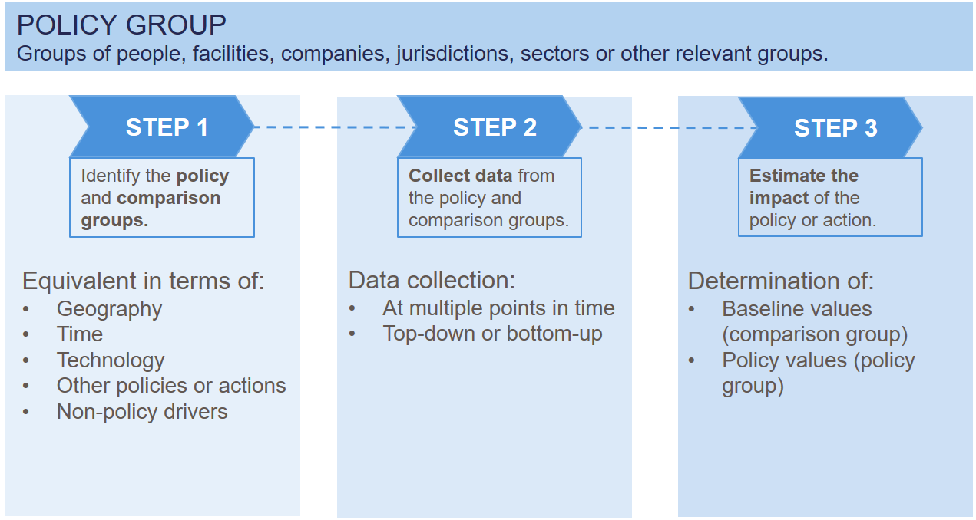

**Chapter 11. Assessing uncertainty**

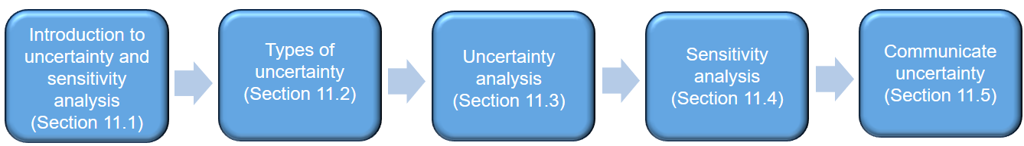

11.1 Introduction to uncertainty analysis and sensitivity analysis

* **Uncertainty analysis**

Systematic procedure to quantify and/or qualify the uncertainty associated with the impact assessment results.

* **Sensitivity analysis**

Varying the value of key (combination of) parameters to determine the impact of such variations on the overall results.

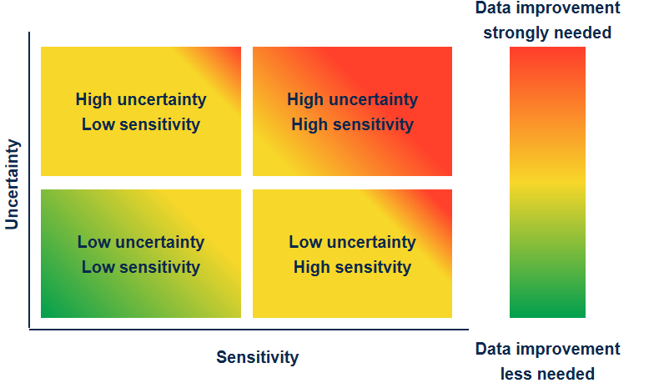

11.2 Three types of uncertainty

* Parameter uncertainty:

It may arise from insufficient data, measurement errors, inaccurate approximation, or geographical and temporal variability. If parameter uncertainty can be determined, it can typically be represented as a probability distribution of possible values that include the chosen value used in the assessment. Individual parameter uncertainties can be propagated to provide a quantitative measure of the uncertainty of the assessment results, which may be represented in the form of a probability distribution.

* Model uncertainty:

Simplifying the real world into a numerical model introduces inaccuracies, and different models are likely to yield different results. The extent of uncertainty can be estimated by comparing the results of different models. Users should acknowledge model uncertainties and report model limitations qualitatively.

* Scenario uncertainty:

Ex-ante assessments involve baseline scenarios and policy scenarios that describe how conditions are expected to develop in the future, while ex-post assessments involve baseline scenarios that describe how conditions would have developed in the past if a policy were not implemented. These scenarios are based on a set of uncertain assumptions, which creates scenario uncertainty. To identify the influence of these assumptions on the results, users should undertake a sensitivity analysis for key parameters in the assumptions (described in Section 11.4).

11.3 Uncertainty analysis

* **Qualitative** uncertainty analysis based on evidence and agreement on evidence
* **Quantitative** uncertainty analysis
  + Default uncertainty estimates for parameters reported in literature.
  + Uncertainty factors for parameters reported in literature.
  + Pedigree matrix approach from life cycle assessment
  + Survey of experts to generate upper- and lower-bound estimates
  + Approaches to combining uncertainties: Monte Carlo simulations, error propagation equations

11.4 Sensitivity analysis

* **Sensitivity analysis:** varying the value of key parameters (or combinations of parameters) to determine the impact of such variations on the overall results.
* Useful for:
  + Understanding the differences resulting from methodological choices and assumptions.
  + Explore model sensitivities to input parameters
* Relative sensitivity for one parameter:

$$x=\frac{∆output/output}{∆input/input}$$

11.5 Communicate uncertainty

* **Usefulness**
  + Help users and stakeholders assess the accuracy and uncertainty of the reported results
  + Inform about the information should be used
* **Reporting requirements**
  + Quantitative estimate or qualitative description of the uncertainty of the results
  + Range of possible outcomes based on different parameter values
  + Appropriate number of significant figures
  + Thorough yet practical effort to communicate key sources of uncertainty
  + Efforts to reduce uncertainty in future revisions of the assessment

**Chapter 12. Monitor the performance of indicators over time**

This chapter is relevant to users who want to:

* determine whether policies are being implemented as planned and having the desired effects across the identified impact categories, to improve implementation and inform future policy design
* assess progress towards achieving SDGs, to adjust current efforts and inform future goal setting
* collect data needed for ex-post assessment of impacts.

12.1 Define approach to monitoring

Two different objectives:

* **Monitor performance of the policy:** Track key indicators over time in relation to historical values, goal values and values at the start of policy implementation to understand whether the policy is on track and being implemented as planned.
* **For ex-post assessment of impacts:** collect data on the indicators and parameters needed (if applicable).

Users can chose to monitor key indicators over time relative to historical values, goal values and/or values at the start of policy implementation.

* **Relative to historical values.** Monitor the trend in a given indicator over time to see whether it is moving in the right direction in relation to past values.
* **Relative to goal values.** Monitor the trend in a given indicator in relation to goal values (defined ex-ante) to see whether goals for that indicator are being achieved.
* **Relative to values at the start of policy implementation.** Monitor the trend in a given indicator before and after a policy is implemented to see whether the policy is having the desired effect.

Tracking of indicators over time may still be useful even if there are no defined goal values for the selected indicator.

12.2 Define indicators for monitoring progress and data collection (12.3)

* All relevant indicators should be clearly described.
* The selected indicators should be monitored in accordance with the monitoring plan and in relation to historical values and/or goal values, and to values at the start of policy/action implementation.
* Parameters should be collected, as needed, for each impact category and each selected indicator included in the assessment boundary (as described in Chapter 5).

12.4 Define the monitoring period and frequency

* The **monitoring period** is the time period over which the policy/action is monitored. At a minimum, the monitoring period should include the policy/action implementation period. Where possible, monitoring should also include pre-policy monitoring of relevant activities before implementation of the policy and post-policy monitoring of relevant activities after the policy implementation period. Depending on the impact categories and indicators being monitored, it may be necessary to monitor some indicators over different time periods than others. In general, the longer the time series of data that is collected, the more robust the assessment will be.
* **The frequency of monitoring** should be based on the needs of decision makers and stakeholders, the type of impact categories and indicators being monitored, cost, and data availability. In general, the more frequently data are collected, the more robust the assessment will be. The monitoring frequency should, in general, be fixed ex-ante for the duration of the monitoring period.

12.5 Create a monitoring plan

**key elements to include:**

* Brief **description** of each indicator; **Source of data** for each indicator and parameter
* Monitoring **period;** Monitoring **frequency;** Measurement or data collection **methods**
* **Historical** value ;**Goal** value; **Entities** or **institutions** responsible for monitoring the respective indicator and collection of parameters

**additional information to include:**

* Methods for generating, storing, collating and reporting data; Level of uncertainty of data and how this uncertainty will be accounted for; Databases, tools or software systems to be used for collecting and managing data; Procedures for internal auditing, quality assurance and quality control, including record keeping and internal documentation procedures, and length of time data will be archived; Whether data are verified and, if so, verification procedures used
* Roles and responsibilities of relevant personnel involved in monitoring; Competencies required and any training needed to ensure that personnel have the necessary skills.

12.6 Monitor indicators[7] over time and tracking progress

Users should **understand distributional impacts on different groups,** and manage trade-offs in cases where policies have positive impacts on some groups and negative impacts on others. Users should report distributional impacts on different groups to identify and manage potential trade-offs. Below is an illustration of steps to tracking progress

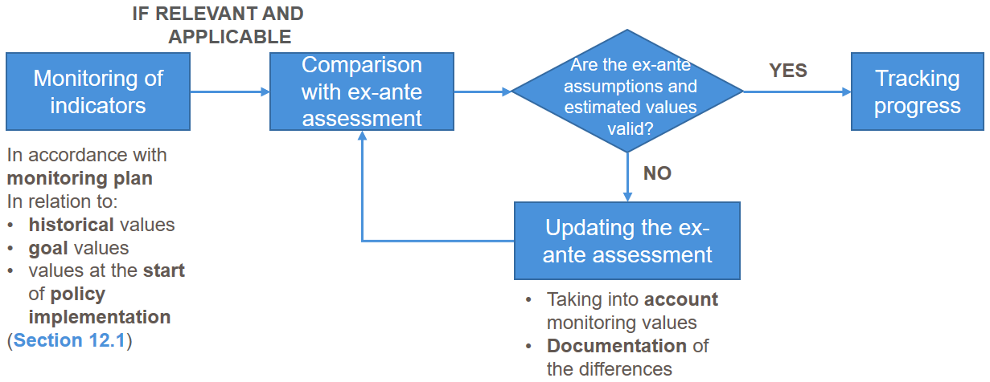

**Chapter 13. Report the results and methodology used**

Users should provide information on elements such as: objectives of the policy or action that they are assessing; key concepts and, steps; describing the policy or action; choosing which impact categories and indicators to assess; starting situation which refers to providing 'a list of **all sustainable** development impacts identified, using a causal chain and/or table format'; qualitatively assessing impacts; estimating the baseline (quantitative approach); estimating impacts ex-ante; estimating impacts ex-post; assessing uncertainty; monitoring performance over time

**Chapter 14: Tracking progress towards SDGs**

The SDGs provide a common framework for reporting on sustainable development impacts. SDGs are increasingly used in the context of NDCs, to report on how climate actions will address the sustainable development concerns of the country. To transparently showcase how their actions are contributed to NDCs and national development plans, it is therefore important for the private sector to report on the sustainable development impacts of their climate actions (let alone the sustainable development impacts that they deliver beyond the climate action itself), using a common framework that governments, stakeholders, investors, and other private and public entities can understand.

The assessment performed following the methodological steps above will provide companies with a detailed overview of the sustainable development impacts of their climate actions, and will allow them to include all relevant, and significant impacts on sustainable development, identified and described as deemed appropriate considering their context. This provides a level of flexibility that a framework, such as the SDG framework, does not allow, as SDG goals and targets are already pre-defined. Nevertheless, at this stage, the company may want to link its impacts so that they speak the “SDG common language”, in order to present the results in a way that can be easily understood by governments, stakeholders, and other entities.

This section explains how to connect the impacts identified to the SDG framework, so that it can become more clear how to company contributes to the journey towards achieving the SDGs. This entails the following steps:

1. Link the impact categories and specific impacts to the SDG targets
2. Score the effect on each individual SDG target, based on the assessment performed
3. Report the total impact on the SDG identified targets using the colour coding
4. If monitoring is part of the goal of the assessment, include indicators for monitoring the impact on the SDG targets identified

The first step consists in pinpointing to which SDG targets, the identified significant impact categories and specific impacts can be connected to. Users can limit their focus on the significant impacts, and exclude the non-significant impact from this part of the assessment.

The connection is made at the SDG targets because this provides a more granular level of detail than the SDG goals (which only identify areas of sustainable development), thus allowing companies to properly capture their contribution to the 2030 Agenda. If some impacts cannot be connected to any SDG targets, it does not mean that they are insignificant, or less relevant in the context of sustainable development. It may just mean that they are not directly relatable, and possible aligned, with the targets of the 2030 Agenda.

Impact categories and specific impacts can have a more or less direct connection to the SDG targets. Here, the aim to include those that have a direct connection to the SDG targets. That means that the impact category, or specific impact, measures what the SDG target describes. The connection can be made both at impact category level, or using the specific impacts identified, according to which level of detail fits better with the one of the SDG targets. In any event, considering the specific impacts identified, can always be help to confirm that the impacts assessed are indeed relevant for the selected SDG target.

If, while performing this step, the user identifies other impacts that would be relevant and significant to measure, we suggest to go back to step on “identification of impact categories” and include these in the assessment boundaries.

Users should explain the reason behind the link between the impact category/specific impact and the SDG target.

Table 1 provides an example on how specific impacts were connected to SDG targets[8], in the context of a study on the sustainable development impacts of solar (off-grid) mini-grids in Kenya[9].

Table 1. Example of how impact categories and specific impacts have been connected to SDG targets, in a study on the sustainable development impacts of solar PV mini-grids in Kenya.

|  |  |  |  |
| --- | --- | --- | --- |
| Impact category | Specific impacts | SDGs target | Reason and link with specific impacts identified |
| Air pollution  (Indoor and Outdoor) | **Particulate matter** | **3.9** By 2030, substantially reduce the number of deaths and illnesses from hazardous chemicals and air, water and soil pollution and contamination  **11.6** By 2030, reduce the adverse per capita environmental impact of cities, including by paying special attention to air quality and municipal and other waste management | **3.9** Air pollution, such as the one avoided in the policy scenario affects the number of deaths and illnesses from air contamination  **11.6** The category air pollution connects with air quality of cities. The SDG indicator of this target is also expressed in PM2.5. |
| Human Toxicity (Air, water and soil) | **Human carcinogenic & non-carcinogenic toxicity** | **3.9** By 2030, substantially reduce the number of deaths and illnesses from hazardous chemicals and air, water and soil pollution and contamination | **3.9** Human toxicity impacts evaluated in the case study causes deaths and illnesses from water, air and soil pollution |
| Accessibility and quality of health care | **Improved access to healthcare due better service in HCs and longer working hours**  **Improved access to healthcare due to the possibility of storing vaccines** | **3.8** Achieve universal health coverage, including financial risk protection, access to quality essential health-care services and access to safe, effective, quality and affordable essential medicines and vaccines for all  **3.b** Support the research and development of vaccines and medicines for the communicable and non‑communicable diseases that primarily affect developing countries, provide access to affordable essential medicines and vaccines, in accordance with the Doha Declaration on the TRIPS Agreement and Public Health, which affirms the right of developing countries to use to the full the provisions in the Agreement on Trade-Related Aspects of Intellectual Property Rights regarding flexibilities to protect public health, and, in particular, provide access to medicines for all | **3.8** The specific impacts on “Improved access to healthcare due better service in HCs and longer working hours” and “Improved access to healthcare due to the possibility of storing vaccines” are connected with accessing quality essential health-care services and vaccines for all  **3.b** The specific impact “Improved access to healthcare due to the possibility of storing vaccines” supports SDG target 3.b by providing better access to vaccines to clinics |
| Access to clean, reliable and affordable energy | **Access to clean, reliable and affordable electricity**  **Access to clean sources of cooking** | **7.1** By 2030, ensure universal access to affordable, reliable and modern energy services  **7.2** By 2030, increase substantially the share of renewable energy in the global energy mix  **7.b** By 2030, expand infrastructure and upgrade technology for supplying modern and sustainable energy services for all in developing countries, in particular least developed countries, small island developing States and landlocked developing countries, in accordance with their respective programmes of support | **7.1** The specific impacts “Access to clean, reliable and affordable electricity” and “Access to clean sources of cooking” contribute to access to affordable, reliable and modern energy services  **7.2** The access to energy evaluated in this impact category will happen through use of renewable energy, which substitutes fossil fuels  **7.b** The access to energy evaluated in this impact category consists of infrastructures and upgrade technologies supplying modern and in developing countries |

Once the mapping is done, users should score the cumulative effect on each SDG target identified, based on the qualitative and quantitative assessment that they have performed on the impact categories and specific impacts. A specific colour coding can be used to characterize the impact on the SDG targets. For qualitative impacts, users should use the colour coding in Figure 3. For quantitative impacts, the relative improvement (%) on the impact category/specific impact should first be calculated using Equation (1), and then, this relative improvement can be expressed using the colour coding in Figure 4.

$Relative improvement \left(\%\right)=\frac{Action scenario impact-Baseline scenario impact}{Baseline scenario impact}$

In case where multiple categories/specific impacts have an effect on the same SDG target, users should take any of these multiplier effect into account.

If the company is assessing more than one climate action, users can choose to first perform the mapping and assessment of SDG contribution for the individual actions, and then assessing their cumulative effect, simply by aggregating the scores of individual actions and accounting for any multiplier effect.



Figure 3. Colour coding for qualitative impacts.

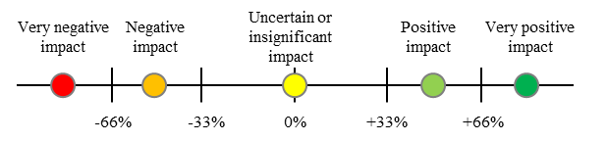

Figure 4. Colour coding for quantitative impacts.

Once this is done, users can report the colour-coded impacts on the SDG targets identified, using the graphic that suits them the best, as in the example in Box 1. A template for reporting impacts on the SDGs as in Figure 3 is provided in the Assessment Template.

**Box 1. Example of reporting impacts using the SDG framework**

A study by Dal Maso et al. (2020) analyzed, through the ICAT Sustainable Development methodology, the environmental and socio-economic implications of the deployment of 146 solar PV mini grids in Kenya. The study assessed quantitatively the impacts on five environmental categories, and qualitatively the impacts on one additional category belonging to the environmental dimension, six categories from the social dimension, and five from the economic dimension.

Using specific targets from the SDG framework, the paper presented a combined qualitative and quantitative analysis of the extent to which mini-grids can contribute to the implementation of Kenya's NDC and to sustainable development priorities. Table 2 reports the list of impact categories included in the study and the SDG targets which they were found to affect.

Table 2. Full list of impact categories analysed and SDG targets connected to each impact category.

|  |  |  |
| --- | --- | --- |
| **Impact category** | **SDG** | **SDG targets** |
| Climate Change mitigation | **9** Industry, Innovation, and Infrastructure**,** **13** Climate action | **9.4,** **13.2** |
| Air pollution(Indoor and Outdoor) | **3** Good health and well-being, **11** Sustainable cities and communities | **3.9,** **11.6** |
| Human Toxicity (Air, water and soil) | **3** Good health and well-being | **3.9** |
| Depletion of non-renewable resources | **12** Responsible consumption and production | **12.2** |
| Waste generation and disposal | **12** Responsible consumption and production | **12.4,** **12.5** |
| Accessibility and quality of health care | **3** Good health and well-being | **3.8, 3.b** |
| Food security | **2** Zero hunger | **2.3** |
| Access to safe drinking water | **6** Clean water and sanitation | **6.1** |
| Access to clean, reliable and affordable energy | **7** Affordable and clean energy | **7.1, 7.2, 7.b** |
| Accessibility and quality of education | **4** Quality education | **4.1,** **4.6**, **4.a, 4.c** |
| Gender equality and empowerment of women | **5** Gender equality**, 11** Sustainable cities and communities | **5.6, 11.7** |
| Economic activity at community level | **8 ,** **1** No poverty | **8.3,** **1.4** |
| Employment | **8** Decent work and economic growth | **8.5** |
| Expenses for electricity | No links have been found | - |
| Income | **10** Reducing inequalities | **10.1** |
| Economic growth | **8** Decent work and economic growth | **8.1** |

Based on the results of the qualitative and quantitative analysis and using the colour coding presented in Figure 3 and 4, in this section, the paper reported the impacts on the SDGs using Figure 5.



*Figure 5. Impacts of a policy for the promotion of solar mini-grids on the SDGs. The boxes represent SDG goals, while the bubbles specific SDG targets. The bubble are coloured according to the significance of the impact on the SDG target*

If monitoring is part of the goal of the assessment, users can identify indicators to monitor the impact on the SDGs. These can be the same indicators identified in the assessment for the impact categories/specific impacts, in which case they should be reported them next to each SDG target identified, as a way to track the impacts on the SDGs, following the templates provided. Users can also identify new indicators, which are more specific for the SDG target, for example using the indicators provided in the SDG framework[10].

1. [Online]. Available: https://www.un.org/sustainabledevelopment/.
2. *(i.e. social and environmental performance, public transparency and legal responsibility)*
3. Kingo, L. (2015). Bringing SMEs into the sustainability process. International Trade Centre. Retrieved from [https://www.intracen.or/rticl/ringing-SMEs-into-the-sustainability-process/](https://www.intracen.org/article/Bringing-SMEs-into-the-sustainability-process/)[CrossRef](http://dx.doi.org/10.18356/8dca91b0-en)
4. Text below is adopted from ICAT Sustainable Development Guidance.

   Source: Rich, D., Olsen, K. H., Soezer, A., Campbell-Duruflé, C., Desgain, D. D., Bakhtiari, F., ... & Dong, Y. (2018). Sustainable Development Guidance. Guidance for assessing the environmental, social and economic impacts of policies and actions.
5. Some indicators for a given impact category are likely to be more feasible to quantify than others. Users should choose indicators for which it is possible to collect data and quantify impacts. If it is not possible to quantify a particular indicator, users should either select a different indicator for the same impact category or qualitatively assess any indicators and specific impacts that cannot be quantified. Indicators will be quantified in the baseline and policy scenario.
6. An ex-ante baseline scenario is a forward-looking baseline scenario, typically established prior to implementation of the policy or action, which is based on forecasts of drivers (such as projected changes in population, economic activity or other drivers that affect the impact category), in addition to historical data.

   An ex-post baseline scenario is a backward-looking baseline scenario established during or after implementation of the policy or action. Ex-post baseline scenarios should include updates to the ex-ante forecasts of drivers, if an ex-ante assessment was first undertaken.
7. For further guidance and examples of indicators that can be used, see:

   the United Nations Sustainable Development Goals website

   the United Nations SDG indicators website, including the global SDG indicators database and list of indicators

   The United Nations Commission on Sustainable Development *Indicators of Sustainable Development: Guidelines and Methodologies*.

   <https://sustainabledevelopment.un.org/sdgs>

   http://unstats.un.org/sdgs

   http://unstats.un.org/sdgs/indicators/database

   http://unstats.un.org/sdgs/indicators/indicators-list

   Available at: <https://sustainabledevelopment.un.org/content/documents/guidelines.pdf>.
8. The SDG targets considered belong to the list of the official 169 SDG targets available [here](https://unstats.un.org/sdgs/indicators/indicators-list/).
9. Mirko Dal Maso, Karen Holm Olsen, Yan Dong, Mathilde Brix Pedersen & Michael Zwicky Hauschild (2020) Sustainable development impacts of nationally determined contributions: assessing the case of mini-grids in Kenya, Climate Policy, 20:7, 815-831, DOI: [10.1080/14693062.2019.1644987](https://doi.org/10.1080/14693062.2019.1644987)
10. The official list of SDG targets and indicators can be found [here](https://unstats.un.org/sdgs/indicators/indicators-list/).