Greenhouse-gas emissions reporting by businesses

Self-assessment template

This assessment template is intended to help business apply either of three “primary protocols” (chapter 1) for reporting on greenhouse-gas emissions: the “GRI 305: emissions” protocol, by the Global Reporting Initiative; the “ISO 14064 standard” by the International Standards Organization; and the “greenhouse-gas protocol corporate accounting and reporting standard”, by the World Resources Institute and the World Business Council for Sustainable Development.
This assessment template helps businesses understand the type of information, including quantitative data, that they should collect and prepare in the context of monitoring and reporting on their greenhouse-gas emissions. The information presented in the following paragraphs has been extracted from the three protocols mentioned above, plus one report (referenced below).

General company information
Company name
Name of the action assessed
Person(s)/organisation(s) that did the assessment
Date of the Inventory assessment
Whether the assessment is an update of a previous assessment, and if so, links to any previous assessments
Objective(s) of the assessment
Intended audience(s) of the assessment
Opportunities for stakeholders to participate in the assessment
Does the assessment apply to an individual action or a package of related actions, and if the latter, which policies and actions are included in the package

Organizational Boundaries
Which of the following approaches your company is using for reporting?
Equity Share | Financial Control | Operational Control

Definitions:
Equity Share: Under the equity share approach, a company accounts for greenhouse-gas emissions from operations according to its share of equity in the operation. The equity share reflects economic interest, which is the extent of rights a company has to the risks and rewards flowing from an operation.
Financial Control: The company has financial control over the operation if the former has the ability to direct the financial and operating policies of the latter with a view to gaining economic benefits from its activities.
Operational Control. A company has operational control over an operation if the former or one of its subsidiaries has the full authority to introduce and implement its operating policies at the operation.

List of all legal entities or facilities over which you (as the reporting company) have equity share, financial control or operational control | Percent equity share in the legal entity | Does the reporting company have financial control? (yes/no) | Does the reporting company have operational control? (yes/no)

If the parent company does not report emissions, consider including an organizational diagram that clearly defines relationship of the reporting subsidiary as well as other subsidiaries

Scope
Which scope did you use in this inventory, and why?
Scope 1  Scope 2  Scope 3 | Why:

Definitions:
Scope 1: emissions from sources owned or controlled by the company.
Scope 2: emissions associated with the use (by the company) of grid-supplied electricity, heat, steam and/or cooling.
Scope 3: emissions associated with the company’s value chain.

Greenhouse gases considered
Accounting of emissions should be independent of any greenhouse-gas trades, such as sales, purchases, transfers, or banking of allowances.

Emission types | Emission volumes  (mtCO₂e) | CO₂ | CH₄ | N₂O | HFCs | PFCs | SF₆
Scope 1
Scope 2
Scope 3

Timing
Specify whether the assessment has been conducted ex-ante, or ex-post, or whether it is a combination of both:
ex-ante
ex-post
combination of ex-ante and ex-post

State the assessment period:

Base year

Year chosen as base year:

If the base year is recalculated, it is recommended to explain the basis of, and context for, the recalculation. If applicable, the company should also state any significance threshold applied for deciding on historic emissions recalculation.

In addition to providing base-year emission estimates (see the table below), it is recommended to clarify concepts and explain any significant emissions changes that trigger base year emissions recalculations. Possible reasons for base-year recalculation include acquisitions/divestitures, outsourcing/insourcing, and changes in reporting boundaries or calculation methodologies, among others.

Base year emissions
Emission types | Emission volumes  (mtCO₂e) | CO₂ | CH₄ | N₂O | HFCs | PFCs | SF₆
Scope 1
Scope 2
Scope 3

Methodologies
Specify the methodologies that your company uses to calculate or measure emissions (see figure 1 overleaf for an overview of types of emission sources).

Figure 1: information on emissions by source types
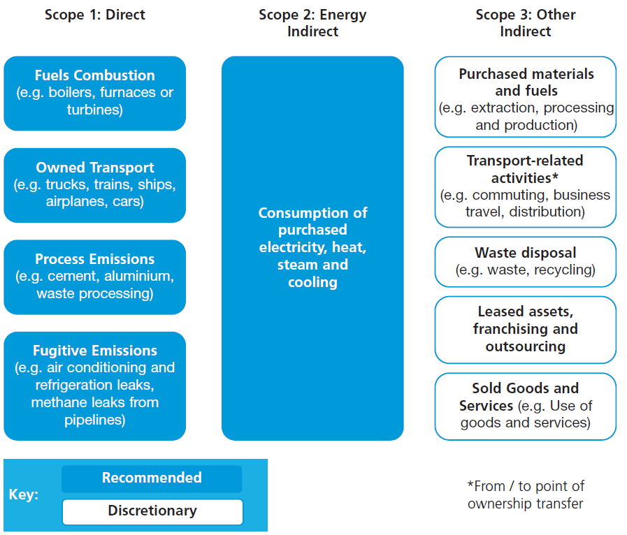
Source: adopted from DEFRA 2009

Inventory of emissions
For scope 1 and scope 2 emissions, the following tables illustrate the type of data that constitutes a typical emissions inventory.

Emissions disaggregated by source types
Scope 1: Direct Emissions from Owned/Controlled Operations
- Direct Emissions from Stationary Combustion
- Direct Emissions from Mobile Combustion
- Direct Emissions from Process Sources
- Direct Emissions from Fugitive Sources
- Direct Emissions from Agricultural Sources
Scope 2: Indirect Emissions from the Use of Purchased Electricity, Steam, Heating and Cooling
- Indirect Emissions from Purchased/Acquired Electricity
- Indirect Emissions from Purchased/Acquired Steam
- Indirect Emissions from Purchased/Acquired Heating
- Indirect Emissions from Purchased/Acquired Cooling

Emissions disaggregated by facility (recommended for individual facilities with stationary combustion emissions over 10,000 mtCO2e)
Facility | Scope 1 emissions

Emissions disaggregated by country
Country | Emissions (specify Scopes included)

Information about emissions-reduction targets
Companies may want to set an emissions-reduction target, to help contextualize their emissions-reduction efforts. Typically, targets are established in absolute or relative (so-called intensity-based) terms.
Definitions:
Absolute targets: they compare greenhouse-gas emission levels in the target year to the levels in the base year.
Intensity targets: they measure decreases in greenhouse-gas emissions relative to a certain parameter, such as the tonne of product produced, or the floor space.

Type of target
What type of target your company is pursuing?
Absolut target
Intensity target

Link of the target to base year:
What type of target base year your company is pursuing?
Fixed target base year
Rolling target base year (the emissions are always compared to the previous year).

Decide on the target boundary
Definition:
The target boundary explains what has been included or covered by the target – for example, the emissions sources and activities concerned, or the geographic operations concerned. Stated differently, a target may coincide with the corporate carbon footprint, or may be a sub-set of it. The latter makes sense, for example, in the context of an emissions trading scheme that regulates only of sub-set of the company’s greenhouse-gas emissions.

What target boundary your company has defined?
Define the target completion date
Third party verification
Has the inventory been verified by an accredited third party?
No
Yes (if yes, fill in verifier contact information below and attach verification statement)
Date of verification: MM/DD/YYYY
Verifier Name:
Contact information:

Offsets
Report on offsets that have been bought or developed outside the inventory boundary
Greenhouse-gas emission levels (mtCO₂e) | Type of offset project | State whether the offsets were verified/certified and/or approved by an external greenhouse-gas emissions-reduction programme

Report on cutbacks inside the inventory boundary that have been traded/transferred as offsets to a third party
Greenhouse-gas emission levels (mtCO₂e) | Type of offset project | State whether the offsets were verified/certified and/or approved by an external greenhouse-gas emissions-reduction programme

Additional information companies may want to provide

Emissions from greenhouse-gases not covered by the Kyoto Protocol

Data and information on the reasons of emissions changes (such as process changes, efficiency improvements, or plant closures) that did not trigger a recalculation of the base year

Greenhouse-gas emissions data for all years between the base year and the reporting year (including details of and reasons for recalculations, if appropriate)

Relevant performance indicators, such as emissions per kilowatt-hour generated, or per unit of turnover

An outline of any greenhouse-gas management or reduction programmes or strategies

Information on any predetermined provisions addressing greenhouse gas-related risks and obligations

An outline of any external assurance provided and a copy of any verification statement, if applicable, of the reported emissions data

Information on the quality of the inventory (notably, regarding the uncertainty of the emission estimates) as well as an outline of policies in place to improve inventory quality

Information on any greenhouse-gas emissions sequestration

Annex: recommended check list of information to report

Relevant information | Category
General company information | company information
State the reporting period covered | reporting period
State the reason for any significant changes in emissions since previous year | changes in emissions and the relevant reasons
State the measuring and reporting approach followed | Organisational boundary
State the scopes included.  Companies should provide a list specifying the activity types included in each scope | Operational scops
Provide detail of any specific exclusions of emissions from scopes 1 and 2 | Operational scops
State the conversion tools / emission factors you used | Operational scops
Provide a breakdown by country of total GHG emissions | Operational scops
Provide detail of any exclusions of countries if a global total is reported | Operational scops
Provide detail of any exclusions of countries if a global total is reported | Operational scops
State the base year chosen and approach used to set the base year | base year
State base year recalculation policy | base year
State appropriate context for any significant emissions changes that trigger base  year emissions recalculation (acquisitions/divestitures, outsourcing/insourcing,  changes in reporting boundaries or calculation methodologies, etc.). | base year
State your target, including scopes covered and target completion date. Provide  a brief overview of progress towards target. | Target
State the name of the person(s) responsible for achievement of this target and their position in your organisation | Target

Relevant information | Category
State the reason for your intensity measurement choice | intensity measurement
State the reason for any significant changes in your intensity measurement from  the previous year | intensity measurement
Provide an outline of any external assurance received and a copy of any  assurance statement, if applicable | External Assurance  Statement
For purchased carbon credits state the reduction in tonnes of CO2e per year | Carbon Offsetting
State the type of carbon credit (Kyoto compliant or non-Kyoto compliant credit)  • If carbon credits are Kyoto-compliant, organisations should specify which  external GHG programme has approved them, provide the name of the  supplier and a hyperlink to the project documentation where possible  • If carbon credits are non-Kyoto compliant, organisations should provide the  name of the supplier, a hyperlink to the project documentation where possible,  details of who developed the quantification methodology, how the project was  validated and verified and how other ‘good quality criteria’ were met. | Carbon Offsetting
For purchased green tariffs state the reduction in tonnes of CO2e per year | green tariffs
State the supplier and the name of the tariff | green tariffs
State the additional carbon saving associated with the tariff as a percentage (%) | green tariffs
State in MWh the amount of electricity generated from owned or controlled sources. State if the owned or controlled source is onsite or offsite. | electricity generation
Source:
DEFRA, 2009: Guidance on how to measure and report your greenhouse gas emissions. Department for Environment, Food, and Rural Affairs. United Kingdom.

The GHG Protocol Corporate Standard makes no specific recommendations as to what constitutes “significant”. However, some greenhouse-gas emission-reduction programmes do specify numerical significance thresholds. For example, in the California Climate Action Registry, the change threshold is 10 percent of the base year emissions, “determined on a cumulative basis from the time the base year is established”.
DEFRA, 2009: Guidance on how to measure and report your greenhouse gas emissions. Department for Environment, Food, and Rural Affairs. United Kingdom.

