Sustainable Development Guidance

Guidance for assessing the environmental, social and economic impacts of policies and actions

May 2021
Assessment template
___________________________________________________________________________________

This template is provided to help users apply the Sustainable Development Guidance. It includes the key assessment tables from the guidance which can be filled out directly. It also contains the key reporting recommendations from Chapter 13. Users should consult the ICAT Sustainable Development Guidance while using this template for additional information about how to carry out the steps.

___________________________________________________________________________________

Overview of the Methodology
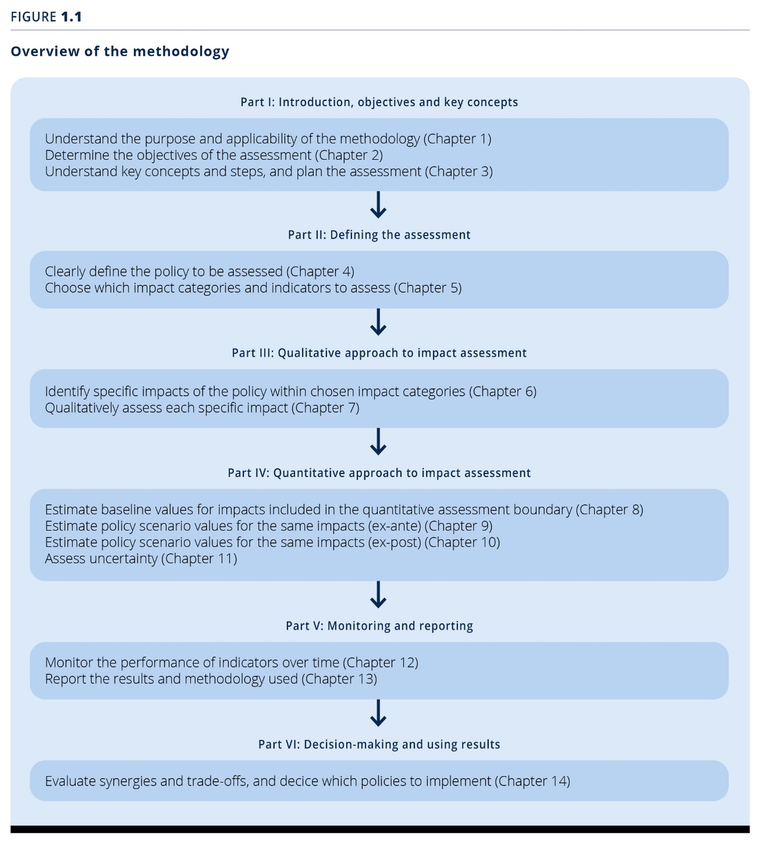
Not all steps of the guidance require actions by the user when assessing the sustainable development impact of a policy. The following template focuses only on those steps that do.

Defining the Assessment Part I & II)

General information on the policy/action/package assessed
General information
- Name the policy or action, or package of policies and/or actions, assessed
- Provide author, date, and type of assessment
Objectives of assessing transformational change (Chapter 2)
- Determine the objective(s) of the assessment
- Determine the intended audience(s) of the assessment
Steps and assessment principles (Chapter 3)
- Determine opportunities for stakeholders to participate in the assessment
- List the principles on which the assessment is based
General information | Assessment information
Name of the policy or action assessed
Person(s)/organisation(s) that did the assessment
Date of the assessment
Whether the assessment is an update of a previous assessment, and if so, links to any previous assessments
Objective(s) of the assessment
Intended audience(s) of the assessment
Whether the assessment consists of a qualitative impact assessment, quantitative impact assessment and/or tracking progress of indicators over time
Opportunities for stakeholders to participate in the assessment
Does the assessment apply to an individual policy/action or a package of related policies/ actions, and if the latter, which policies and actions are included in the package
Whether the assessment is ex-ante, ex-post, or a combination of ex-ante and ex-post
The assessment period

Recommended information to describe the policy or action being assessed (Chapter 4)
- Provide general information on wether the assessment applies to an individual policy/action or a package of related policies/ actions.
If a package is assessed, name which policies and actions are included in the package. The template based on Table 4.1 of the Transformational Change Guidance (see below) contains recommended information that should be provided for an effective assessment.
(Section 4.1, 4.2)
- Choose if you will be conducting an ex-ante assessment, an ex-post assessment, or a combination of both (SSection 4.3)
- Define the assessment boundary and period
- If possible, provide additional information on the policy/action/package through the second template below.

Note: See Table 4.1 of the Sustainable Development Guidance for an example of filling out the template.
Information | Description | Assessment information
Title of the policy or action | Policy or action name
Type of policy or action | The type of policy or action, such as those presented in Table 1.1, or other categories of policies or actions that may be more relevant
Description of specific interventions | The specific intervention(s) carried out as part of the policy or action, such as the technologies, processes or practices implemented to achieve the policy or action
Status of the policy or action | Whether the policy or action is planned, adopted or implemented
Date of implementation | The date the policy or action comes into effect (not the date that any supporting legislation is enacted)
Date of completion (if applicable) | If applicable, the date the policy or action ceases, such as the date a tax is no longer levied or the end date of an incentive scheme with a limited duration (not the date that the policy/action no longer has an impact)
Implementing entity or entities | The entity or entities that implement(s) the policy or action, including the role of various local, subnational, national, international or any other entities
Objectives and intended impacts or benefits of the policy or action | The intended impact(s) or benefit(s) the policy or action intends to achieve (e.g., the purpose stated in the legislation or regulation)
Level of the policy or action | The level of implementation, such as national level, subnational level, city level, sector level or project level
Geographic coverage | The jurisdiction or geographic area where the policy or action is implemented or enforced, which may be more limited than all the jurisdictions where the policy or action has an impact
Sectors targeted | Which sectors or subsectors are targeted
Other related policies or actions | Other policies or actions that may interact with the policy or action being assessed

Note: See Table 4.2 of the Sustainable Development Guidance for an example of filling out the template.
Information | Description | Assessment information
Relevant SDGs | Sustainable Development Goals the policy or action focuses on or contributes to
Specific intended targets, such as intended level of indicators | Target level of key indicators, if applicable
Title of establishing legislation, regulations, or other founding documents | The name(s) of legislation or regulations authorising or establishing the policy or action (or other founding documents if there is no legislative basis)
Monitoring, reporting and verification procedures | References to any monitoring, reporting and verification procedures associated with implementing the policy or action
Enforcement mechanisms | Any enforcement or compliance procedures, such as penalties for noncompliance
Reference to relevant documents | Information to allow practitioners and other interested parties to access any guidance documents related to the policy or action (e.g., through websites)
The broader context or significance of the policy or action | Broader context for understanding the policy or action
Key stakeholders | Key stakeholder groups affected by the policy or action
Other relevant information | Any other relevant information

Choosing which impact categories and indicators to assess (Chapter 5)
- Include all sustainable development impact categories in the assessment that are expected to be (1) relevant (based on the objectives of the assessment, national or local policy objectives, sustainable development goals and priorities, local circumstances, and stakeholder priorities) and (2) significantly affected by the policy (either positively or negatively) (Section 5.1)
- Consult stakeholders when choosing which impact categories to assess

- Based on your choice of categories, select relevant indicators for each chosen category. Note that one or more indicators may be relevant to a category. For qualitative assessment, you should select indicators; for a quantitative assessment, you must select indicators. A list of indicators and helpful additional documents can be found at https://unstats.un.org/sdgs (Section 5.2)

Note: Add/remove impact categories as appropriate. The list of impact categories should be as comprehensive as possible. See Table 5.1 and Table 5.5 of the Sustainable Development Guidance for a non-exhaustive list of impact categories and indicators. See Table 5.2 for for an example of filling out the template.
Dimension | Impact category | Relevant? | Significant? | Included in the assessment boundary? | Brief description (rationale for the determination of relevance and significance) and justification for exclusions (of impact categories that may be relevant, significant or identified by stakeholders) | Indicator(s) selected for each impact category included in the assessment
Environmental
Social

Economic

Qualitative Impact Assessment (Part III)

Sustainable development impacts identified in the assessment (Chapter 6)
- Identify all potential sustainable development impacts of the policy/action/package within each impact category included in the assessment (see previous chapter)
- To ensure comprehensiveness, identified impacts should be:
  - Positive and negative;
  - Intended and unintended;
  - In- and out-of-jurisdiction;
  - Short term and long term
Table 6.1 of the Sustainable Development Guidance outlines these different types of impacts, provides definitions and gives examples.
- Users should also develop a causal chain to show cause-and-effect relationships between the policy or action and various specific impacts. Figures 6.3, 6.4 and 6.5 of the Sustainable Development Guidance outline how a causal chain may be set up.
Note: Add or remove the rows for impact categories and specific impacts as appropriate. See Table 6.3 of the Sustainable Development Guidance for an example of filling out the template.
Impact categories included in the assessment (from Table 5.1) | Specific impacts identified (within each impact category) | In- or out-of-jurisdiction | Scope 1-2-3  (optional) | Type of impacts (optional) | Methods/ sources used to identify impacts (optional)

Qualitative impact assessment (Chapter 7)
- Include all impact categories included in Chapter 5 and all specific impacts identified in Chapter 6 in the qualitative assessment boundary
- Define the assessment period
- Characterize each impact identified in Chapter 6 based on
  - the likelihood that each impact will occur,
  - the magnitude of each impact and
  - the nature of the change (positive or negative)
Section 7.3 of the Sustainable Development Guidance outlines the characterization process step-wise
- Based on the assessment of likelihood and magnitude, determine which identified impacts are significant, in consultation with stakeholders
- Summarize the qualitative assessment results for each impact category, taking into account all significant impacts
- Separately assess the impacts of the policy on different groups in society, where relevant
Note: Add or remove the rows for impact categories and specific impacts as appropriate. See Table 7.4 of the Sustainable Development Guidance for an example of filling out the template.
Chapter 5 | Chapter 6 (Identify specific impacts) |  |  | Chapter 7 (Qualitatively assessing impacts) |  |  |  |  |  | Chapter 8 (Defining the quantitative assessment boundary)
Impact categories included in the assessment | Specific impacts identified | In- or out-of-jurisdiction | Type of impacts (optional) | Likelihood | Magnitude | Positive or negative impact | Significant? | Summary of qualitative assessment results for each impact category | Methods/sources used | Feasible to quantify? | Included in the quantitative assessment boundary? | Justification for exclusions or other comments

Quantitative Impact Assessment (Part IV)

Estimating the baseline (Chapter 8)

Quantitative assessment boundary (i.e., the set of impact categories, specific impacts and indicators to be quantified) (Section 8.1 of the ICAT Sustainable Development Guidance)
- Include all significant impacts in the quantitative assessment boundary, where feasible to assess
- Define one or more appropriate indicators for each impact category included in the quantitative assessment boundary
Selected indicators should be relevant to quantify the identified impacts, and data collection should be possible
- Define the assessment period
Note: Add or remove rows for impact categories and specific impacts as appropriate. See Table 8.1 and A.1 of the Sustainable Development Guidance for an example of filling out the template.
Impact categories included in the assessment | Specific impacts included in the quantitative assessment boundary | Indicator(s) to quantify

Assessment methods
- Choose an assessment method for each identified indicator
- See Section 8.2 of the ICAT SD Guidance for outlines of different assessment methods

Baseline scenario assumptions (Chapter 8, Section 8.3)
- Defining a baseline scenario is indispensable regardless of ex-ante or ex-post assessments of impacts
- Steps to define a baseline scenario:
  - Select a desired level of accuracy and complexity
  - Define the most likely baseline scenario for each indicator
  - Define the methods and parameters needed to estimate baseline values
  - Collect data for each indicator
  - Estimate baseline values for each indicator

Note: Add or remove the rows of impact categories as appropriate. See Table A.2 of the Sustainable Development Guidance for an example of filling out the template.

Impact categories | Baseline scenario assumptions
General baseline assumptions
Description of the baseline scenario and a justification for why it is considered to be the most likely scenario
Policies, actions and projects included in the baseline scenario; justification for any implemented or adopted policies, actions or projects with a potentially significant impact that are excluded from a baseline scenario; any planned policies included in the baseline scenario
Non-policy drivers included in the baseline scenario; justification for any relevant non-policy drivers that are excluded
Rationale for the choice of whether to estimate new baseline values and assumptions or to use published baseline values and assumptions
Impact category specific baseline assumptions
[Name of impact category]
[Name of impact category]
[Name of impact category]
[Name of impact category]
[Name of impact category]
[Name of impact category]

Estimated net impact of a policy scenario ex-ante (Chapter 9)
- Define a policy scenario that represents the conditions most likely to occur in the presence of the policy over time for each indicator being estimated, taking into account all specific impacts included in the quantitative assessment boundary
- Estimate the net impact of the policy on each indicator by subtracting baseline values from policy scenario values, taking into account all specific impacts included in the quantitative assessment boundary
- Separately assess the impacts of the policy on different groups in society, where relevant
- Chapter 9 of the Sustainable Development Guidance is structured around the scenario method, but the steps outlined are also helpful for the deemed estimates method.
Scenario method
(See Section 8.2.1 of the ICAT SD guidance)
Note: Use one table for each indicator and specific impact. Create additional tables as needed to include all indicators and all specific impacts included in the assessment. Edit the assessment period (e.g., years) as appropriate. This format uses the scenario method. See Appendix A for examples. If relevant, the results should include distributional impacts on different groups in society and the total in-jurisdiction impact separately from total out-of-jurisdiction impact, if feasible.
Impact category #1 | [Name of impact category]
Indicator #1
Specific impact
Assessment method | Scenario method
Equation
Parameters needed
Assumptions | [Description of the policy scenario and specific assumptions made]
Assessment period | 2016 | 2017 | 2018 | 2019 | 2020 | 2021 | 2022 | 2023 | 2024 | 2025 | Cumulative impact
Baseline values |  |  |  |  |  |  |  |  |  |  | N/A
Policy scenario values |  |  |  |  |  |  |  |  |  |  | N/A
Change in indicator per year from the policy |  |  |  |  |  |  |  |  |  |  | [Sum]

Deemed estimates method
(See Section 8.2.2)

Note: Use one table for each indicator and specific impact. Create additional tables as needed to include all indicators and all specific impacts included in the assessment. This format uses the deemed estimates method. See Appendix A for examples. If relevant, the results should include distributional impacts on different groups in society and the total in-jurisdiction impact separately from total out-of-jurisdiction impact, if feasible.
Impact category #1 | [Name of impact category]
Indicator #1
Specific impact
Assessment method | Deemed estimates method
Equation
Parameters needed
Assumptions | [Description of the policy scenario and specific assumptions made]
Assessment period | 2016 | 2017 | 2018 | 2019 | 2020 | 2021 | 2022 | 2023 | 2024 | 2025 | Cumulative impact
Change in indicator per year from the policy |  |  |  |  |  |  |  |  |  |  | [Sum]

Estimated impact of the policy or action on each indicator included in the assessment (Section 9.3)
Follow these steps for each indicator being estimated:
- Estimate baseline values relating to each specific impact in the quantitative assessment boundary (as described in Chapter 8).
- Estimate policy scenario values relating to each specific impact in the quantitative assessment boundary.
- Subtract baseline values from policy scenario values to estimate the impact of the policy for each specific impact.
- Aggregate across all specific impacts to estimate the total net impact of the policy on a given indicator, which represents the change in the impact category, where feasible:
Net (aggregated) impact of a policy on the chosen indicator =∑ estimated change for each specific impact included in the assessment boundary
- Repeat the process for each indicator in the assessment boundary.
Note: Add or remove rows of impact categories and indicators quantified as appropriate. See Table 9.1 of the Sustainable Development Guidance for an example of filling out the template.

Impact category | Indicator quantified | Estimated impact  (Cumulative impact over the assessment period) | A quantitative estimate or qualitative description of the uncertainty and sensitivity of the results

Estimating impacts ex-post (Chapter 10)
- Recalculate baseline values (as described in Chapter 8) every time an ex-post assessment is undertaken
- Estimate the net impact of the policy on each indicator in the quantitative assessment boundary by subtracting baseline values from policy scenario values, taking into account all specific impacts included in the quantitative assessment boundary
- Separately assess the impacts of the policy on different groups in society, where relevant
- For users following the comparison group method, identify an equivalent comparison group for each impact category in the assessment boundary, and collect data from the comparison group and the policy group over the assessment period for each indicator included in the assessment boundary
Note: For ex-post estimation of impacts, the same templates may be used. However, ex-post assessment involves monitored or observed results. See Chapter 10 of the Sustainable Development Guidance for guidance on ex-post impact assessment.

Assessing uncertainty (Chapter 11)
- Understanding uncertainty is important for properly interpreting and communicating the results of the assessment.
- Assess the uncertainty of the assessment results, either qualitatively or quantitatively (Section 11.3)
- For quantitative assessments, conduct a sensitivity analysis for key parameters and assumptions in the assessment (Section 11.4)
- The template above contains a column for explaining sensitivity/uncertainty that should be used to present the result of your assessment
- Communicating the results of your sensitivity/uncertainty assessment is crucial to help users/stakeholders interpret your information properly (section 11.5), and should therefore be an integral part of your monitoring and reporting (see Part 5 below)

Monitoring and reporting (Part 5)
- Define indicators that will be used to track performance of the policy over time for each impact category included in the assessment
- If estimating impacts ex-post, collect data needed for ex-post assessment
- Create a plan for monitoring indicators
- Monitor each of the indicators over time, in accordance with the monitoring plan
- Separately monitor indicators for different groups in society, where relevant

Selected indicators and explanation of chosen indicator (Section 12.2)
Note: Add or remove rows of impact categories and indicators as appropriate. See Table 12.1 of the Sustainable Development Guidance for an example of filling out the template.
Impact category | Indicator(s) | Explanation of chosen indicator

Monitoring template for the selected indicators and parameters (Section 12.2)
Note: Add or remove rows of indicators as appropriate. See Table 12.2 of the Sustainable Development Guidance for an example of filling out the template.
Indicator | Source of data | Monitoring frequency | Measurement method | Responsible entity or institution | Historical value in year X | Goal value for year Y

Additional information related to monitoring and assessment
Note: Create additional tables as needed to include all impact categories included in the assessment.
Impact category #1
The performance of the policy or action over time, as measured by the indicators, and whether the performance of the policy or action is on track relative to expectations
Whether the assumptions on key indicators within the ex-ante assessment remain valid, if applicable
Trends in indicators for different groups in society
The method or approach used to assess uncertainty.

Monitoring template with SDGs (Section 12.7)
- Link the impact categories and specific impacts to the SDG targets
- Score the effect on each individual SDG target, based on the assessment performed
- Report the total impact on the SDG identified targets using the colour coding
- If monitoring is part of the goal of the assessment, include indicators for monitoring the impact on the SDG targets identified
Detailed table to explain the links between impact categories/specific impacts, and SDG targets (normally for Appendix, for improved transparency)
Impact category | Specific impacts | SDGs target(s) | Reason and link with specific impacts identified
Summary table the links between impact categories/specific impacts, and SDG targets
Impact category | SDG | SDGs target(s)

Tables with legend for colour coding
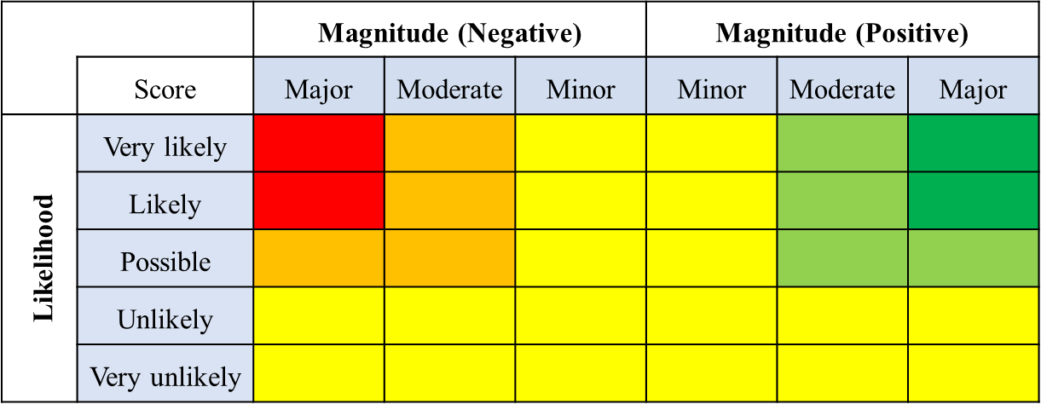
Colour coding for qualitative impacts.
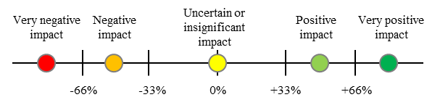
Colour coding for quantitative impacts.

Figure (1) for reporting SDG impacts (please ask UNEP DTU for the editable version in ppt).
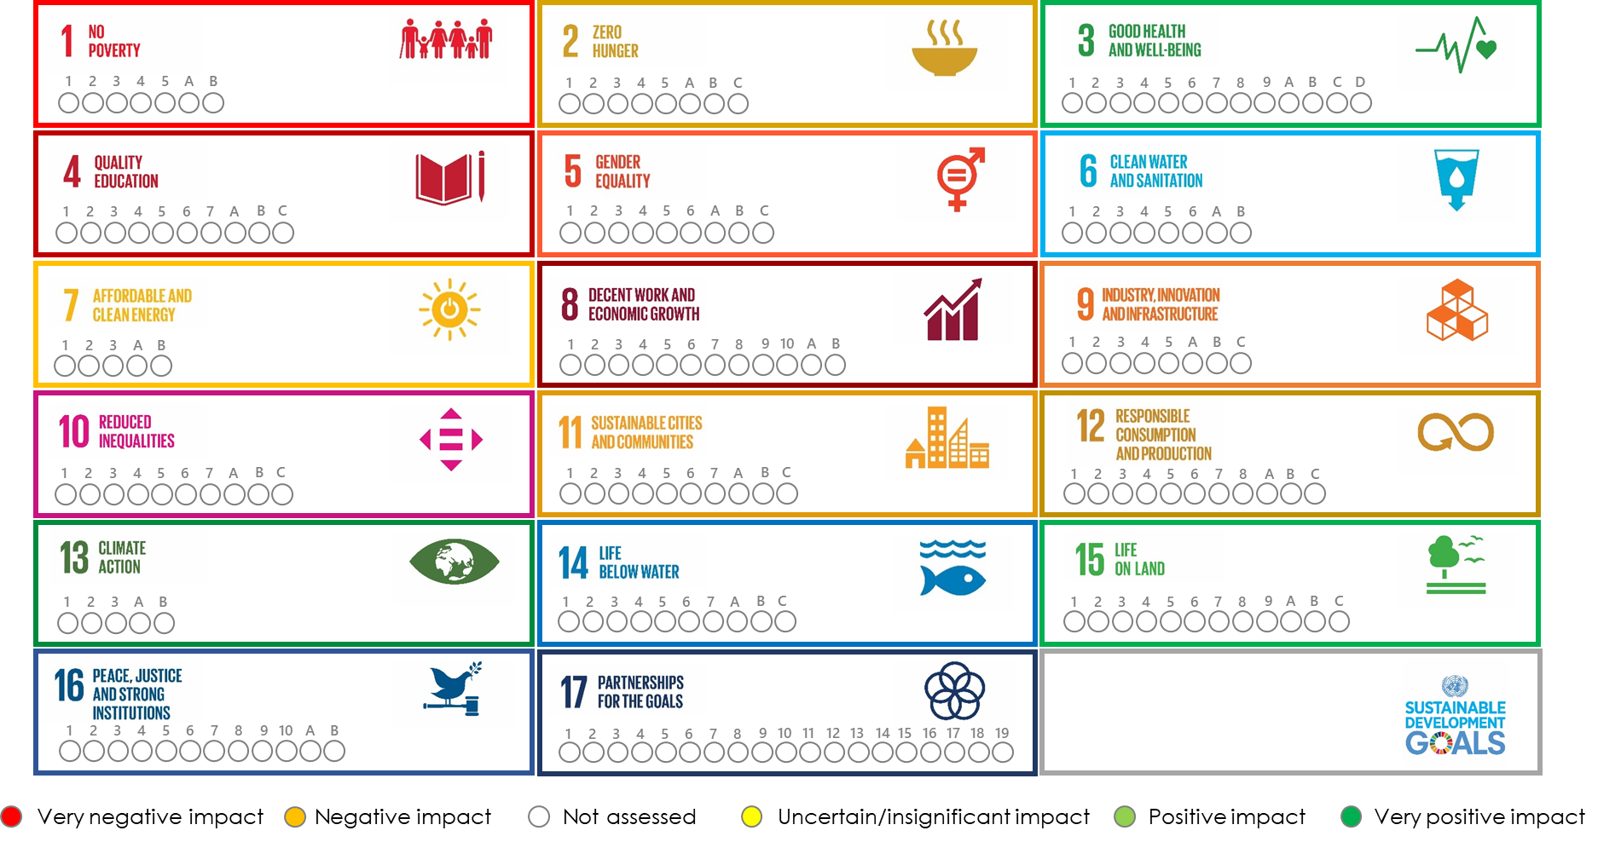

Note: Add or remove the rows as appropriate. See Tables 12.3 and 12.4 of the Sustainable Development Guidance for an example of filling out the template.

Table below for describing how to monitor the indicators on the SDGs.

SDG targets | Correspoding impact categories (specific impact, if relevant) | Indicator(s) | Indicator from the SDG official list? (yes/no) | Source of data | Monitoring frequency | Measurement method | Responsible entity or institution | Historical value in year X | Goal value for year Y

